Perfect weather for
Tall Ship Cruise

Blue skies and light winds made the perfect day for the Society's 10th Sailing Cruise on the Empire Sandy on September 2. Both morning and afternoon cruises were filled to capacity with everyone thoroughly enjoying themselves on the two voyages out on Lake Ontario. On board the ship we were treated to the stirring sound of the pipes of Bill Cockburn and John Wakefield and to the intricate steps of the Georgina Finlay Dancers.
The event raised over $3,000 for our cause so a big round of applause is due to all members and friends who came out to give support. Special thanks is also due to Robert Stewart for publicizing the event, to Alan McKenzie for organizing it and to Ed and Anne Patrick for enduring the heat while keeping a track of tickets and bookings at the dockside.
The annual cruises commemorate the arrival of the "Hector" in Canada in 1773. The "Hector" carried the first wave of Scottish settlers to Pictou, Nova Scotia. In later years, that first wave became a flood of Scots to Canada.
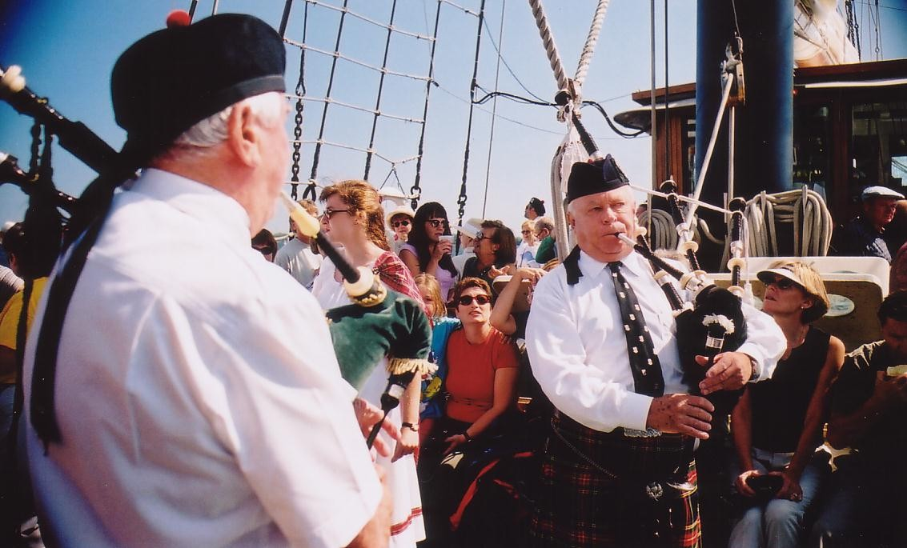
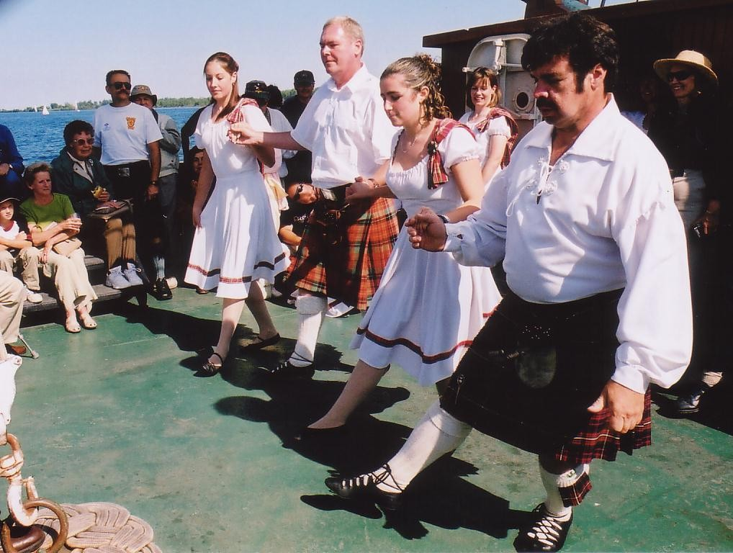
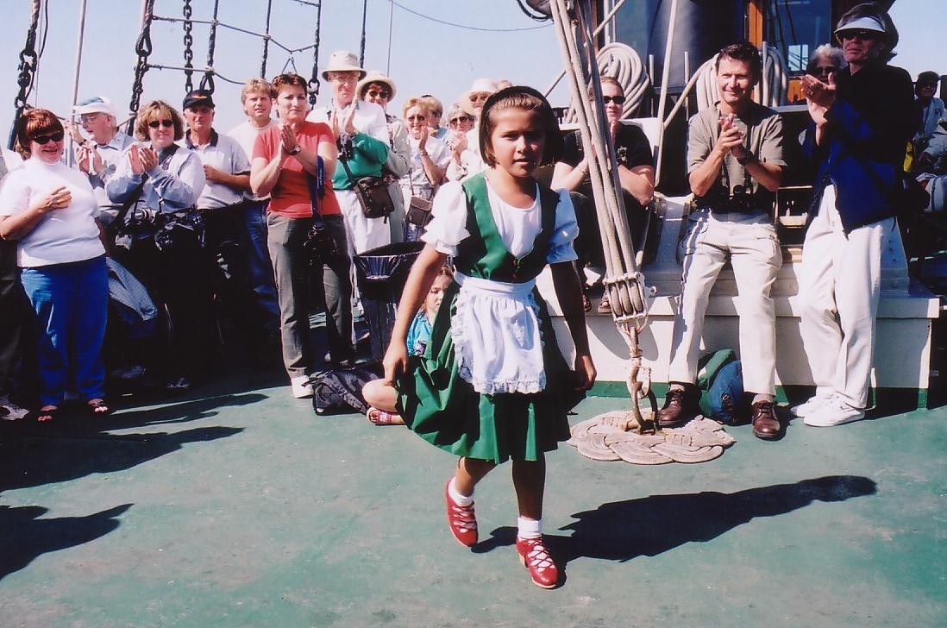

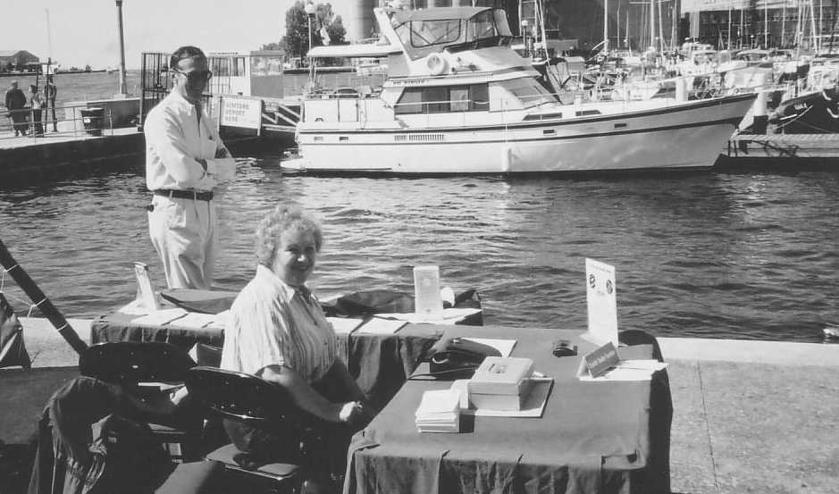

Photos:
A full shipload of enthusiastic participants wait for the ship to sail from Toronto's Harbourfront (top right). Tall ship Empire Sandy rocks to the steps of traditional Highland and Scottish Country dancing (middle two on right). Ed and Anne Patrick on duty at the dock (bottom right). University of Guelph Scottish Studies professor Dr. Kevin James and his fiancée Monica Rieck (above) sun themselves on board the ship while listening to the stirring sounds from pipers Bill Cockburn and John Wakefield (top left).
6 The Scots Canadian
