The following articles on the Dewar Sept of the Clan Macnab were taken from several sources. No attempt has been made to consolidate the articles; instead they are presented as in the original source, which is given at the beginning of each section. Hence there will be some duplication of material. David Rorer

Dewar means roughly “custodian” and is derived from the Gallic “Deoradh,” a word originally meaning “stranger” or “wanderer,” probably because the person so named carried St. Fillan’s relics far a field for special purposes. Later, the meaning of the word altered to “custodian.” The relics they guarded were the Quigrich (Pastoral staff); the Bernane (chapel Bell), the Fergy (possibly St. Fillan’s portable alter), the Mayne (St. Fillan’s arm bone), the Maser (St. Fillan’s manuscript).

There were, of course other Dewars than the Dewars of St. Fillan and the name today is most familiar as that of a blended scotch whisky produced by John Dewar and Sons Ltd

**St. Fillan** is mentioned in the *Encyclopedia Britannica*, 14th edition of 1926, as follows:

***Fillan, Saint or Faelan***, the name of two Scottish saints, of Irish origin, whose lives are of a legendary character.

The St. Fillan whose feast is kept on June 20 had churches dedicated to him at Ballyheyland, Queen’s county, Ireland, and at Loch Earn, Perthshire (see map of Glen Dochart). The other, who is commerated on January 9, was specially venerated at Cluain Mavscua in County Westmeath, Ireland. Also beginning about the 8th or 9th century at Strathfillan, Perthshire, Scotland, where there was an ancient monastery dedicated to him. This monastery became a cell of the abbey of canons regular at Inchaffray, and was supposed to posses the Saint’s crozier or staff, the head of which is now deposited in the National museum of the Society of Antiquaries of Scotland.

The legend of the second St. Fillan is given in the Bollandist *Acta SS.* (1643) and in D. O’Hanlon, *Lives of Irish* Saints (Dublin 1825)

.

In **Clan MacNab a Short History**, written by James Charles Macnab of Macnab, 23rd Chief of the Clan, he has the following to say about St Fillan and the Dewars:

There were two saints called Fillan. The earlier was an Irish Celt of the race of Aengus, King of Leinster. He died on June 22, 520 A.D. His chapel and grave are at Dundurn at the eastern end of Loch Earn. His Font is in Dundurn Church and his “chair” is on St. Fillan’s Hill, where are also his spring and “basin.”

The later St Fillan was a Scot, the son of Eerach or Ferdach of the race of Fiatach Finn. He succeeded St. Mundus as Abbot of Kilmun and then moved to Glendochart whence his mother Kentigerna, the most devout of women, retired to the Nun’s Island on Loch Lomond and died in 734 A.D. The name Fillan (Faolan) means “Wolf Cub.”

The ruins of his chapel are at Kirkton between Tyndurm and Crianlarich in Strathfillan. His “pool” and “stone bed,” which were supposed to cure the insane, are still there. His pastoral staff, or crozier, (the Quigreach), which was carried before the Clan in battle, and his bell are in the National Museum in Edinburgh. His left arm, which was luminous enough to help him to write at night, was enshrined in a casket after his death.

It is said that King Robert the Bruce wished to have the relic of his arm with him at Bannockburn.[1] The casket was sent empty[2] but the arm followed it miraculously and was considered by the King to have helped him greatly to gain the victory.

His “healing stones” are at the Tweed Mill, Dochart Bridge, Killin (now the Breadalbane Folklore Center ). He died on 9 January 703 A.D. Other relics of St. Fillan, important to the Clan still exist.

There were several Dewar families living in Strathfillan and Glendochart at the time of Bannockburn and before, each being responsible for a different relic. There is a Croftandeoir (Dewar’s croft) shown on the 1832 plan of Kinnell Estate.

In 1336, Alexander Menzies, Lord of Glendochart issued a missive confirming to “Donald Mcsobrell Dewar Cogerach” part of the lands of Ewich in Strathfillan.

In 1428, an enquiry by the Baillie of Glendochart found that Finlay Jore (Doire or Dewar) should have for all time have a “boll”[3] of meal from every inhabitant of Glendochart holding more than a half merkland of ground. [4] James III confirmed these rights by charter in 1487 to one Malise Doir.

In 1551, Queen Mary issued an order assessing for tax “Malise Dewar, the forty shilling land of Ewich...” At that time there were five hereditary Dewars with land in Strathfillan and Glendochart. Dewar Quigrich at Ewich; Dewar Bernane at Suie; Dewar Fergy at Audilyne, Dewar Messer at Killin.

There are other Dewars who settled along Loch Tay and east to the area of Weem and Aberfeldy. Some of these regard themselves as part of Clan Menzies.

**The Macandeoir**

The Mac-an-deoirs or Dewar’s of Glendochart were the hereditary custodians of the *Bachuil*, crozier, or *cuigreach*[5] of St. Fillan. This crozier is a relic of the greatest antiquity, and also bore the designation of the *Fearachd.* Hence the Mac-an-deoirs were also known as *Deóraich-naFearachd.* The crozier of St. Fillan, of which the Dewars were the hereditary custodians, is one of the most venerable of Scottish relics. It dates back to the seventh century A.D. and is only exceeded in antiquity by the famous Coronation Stone of Destiny of Scone. The custody of the holy relic conferred some very important privileges on its custodians. These were confirmed and added to by King Robert the Bruce after the Battle of Bannockburn. Though on that occasion the Macnabs were opponents of the Bruce, the Dewars were present on the Scottish side and had the crozier along with them. It is traditionally reported that previous to the Battle of Bannockburn King Robert the Bruce and his army received the sacrament, during the administration of which the corzier of St. Fillan was elevated in full sight of the army. In 1314, as a thank offering for the victory on Bannockburn, King Robert erected a church at Tyndrum in Strathfillan, and dedicated it to St. Fillan. After the Reformation the crozier was faithfully guarded by its hereditary custodians, the Dewars, and was passed on from father to son. At the beginning of the nineteenth century the sept was broken up and left the country. Some of the emigrated to America, among them the custodian of the cuigreach, and so the relic was lost sight of for a time. Some years ago, however, Sir Daniel Wilson, while hunting on the shores of Lake Superior, took refuge in the hut of a Scottish settler named Alexander Dewar. Sir Daniel found that the settler's family had once lived in Inch Buie, that he was the custodian of St. Fillan's crozier, and that he had the relic in the house. It was then exhibited to Sir Daniel, and in 1876 was acquired by the Society of Antiquaries of Scotland, in whose museum at Edinburgh it has now found a resting-place. The hereditary keeper of the cuigreach of St. Fillan duly received in 1930; armorial insignia indicative of his ancient office (Lyon Register, XXVII. p 128), although he no longer holds St. Fillian's crozier. The inquest of 1428 shows that the *Deoir-Cuigreach* was the *Co-arb* (and, as it explains, heir) of St. Fillan, *i.e.* in the Celtic sense, Hereditary Abbot. He and the Baron of the Bachuil of St. Moluag of Lismore seem to be the only surviving prelates of the old Celtic Church

**Gilfillan*,* "Servant of St. Fillan"**

In D. Mitchell's *History of the Highlands* he states the following:

“The Macnabs should probably be recognized as the lay abbots of Glendochart. In their genealogy we find the name *Gillefhaolain* or the servant of St. Fillan, a fact which shows their association with the monastery of St. Fillan. In the time of William the Lyon the Abbot of Glendochart was an important individual, and ranked with the neighboring Earls of Athol and Menteath”. (He was, or course, not a "lay" abbot, but a hereditary tribal abbot.)

McClellan, derived from the same source as Gilfillan, is a clan rather than a sept name. A colony of Macellans is to be found in Morar, Inverness-shire. There are also some MacLellans to be found in the Aberfeldy district of Perthshire. The Clelands of Cleland, who were hereditary foresters to the Earls of Douglas, likewise derive their name from St Fillan.

**The Relics of St. Fillan**

The relics of the Founder Saint were the essential insignia of a Celtic abbacy, and were sometimes given in hereditary custody with a toft[6] of land to younger branches of the abbatial family. Such hereditary custodians were styled “dewars,” which often became their surname. In Glendochart there were five separate hereditary Dewars, each with a separate relic of St. Fillan (the pastoral staff, the bell, the arm bone, the ‘meser’ and the ‘fearg’: they were presumably cadets of the hereditary Abbots of Glendochart, who’s principal heirs were the Macnabs of Macnab.

The Bell of St. Fillan, known as the *Bearnan*[7] or ‘Little Capped One’. As late as 1488, it was carried in the sacred pageant at King James IV’s Coronation. It was in the hereditary custody of a Dewar whose toft is referred to in 1640 as “Dewar-Vernan’s Croft,”[8] at Suie in Glendochart.

*Feart* means ‘Wrath’, and it is uncertain what relic acquired this by-name. Its hereditary Dewars had their toft at Dewar-na-fargs-croft, which is referred to as late as 1632, and was at Auchlyne in Glendochart where the ruins of their *Icaibel-na-Fairg* or Chapel of the Fearg can still be seen. It has been suggested that the ‘meser’ was a *meise* or portable alter, but it seems more likely that it was the saint’s missal, miraculously written by night. In 1468 a MacGregor certified to the Baillie of Glendochart that he held the tack of the lands of Corehynan from the ‘Deore of the Meser’.[9]

The saint’s arm bone was known as the *Main*, and his toft at Killin is referred to in 1640 as ‘Dewar-na-Mans-croft’ and in 1670 as ‘Dewar-na-Maynes-croft’. King Robert Bruce prayed in the Priory of Strathfillan while a fugitive and attributed his escape from the MacDougall’s to the saint’s intervention. Accordingly the silver shrine of the saint’s arm bone was brought to spend the night in the king’s tent on the eve of Bannockburn, and was born to the battlefield by the Abbot of Inchaffray himself. This enshrined arm-bone must have been an especially interesting relic, as we are told that once upon a time, ‘when the saint was in his cell after sundown, a lay brother was sent to call him to supper. The messenger, curious to know what St. Fillan was doing, looked through a chink in the wall, and was astonished to see him writing by means of a light that streamed from his left arm.[10] Next day a tame crane that was kept by the holy fraternity pecked out the eye of the lay brother who was guilty of spying upon the saint, and rendered him quite blind, but at the request of the rest of the brethren St. Fillan restored his sight to the erring one’.

In 1549, the Privy Council protected “Malise Doir of Quickrich: (malise Dewar of *Coigreach*, the saint’s pastoral staff) “Archibald Doir of Fargy” and “Malcolm Doir of Bernane” (*Bearnan* was the saint’s bell) from having to hand over their sacred relics to the Prior of Strathfillan. St. Fillan's bell and pastoral staff are now in the National Museum of Antiquities of Scotland, in Edinburgh.

The elaborate silver crozier-head was added to encase St. Fillan’s pastoral staff[11], probably in the 14th century. In 1336, the Menzies chief, as then overlord of Glendochart, confirmed Donald McSobrell, Dewar Cogerach, in the lands of Ewich in Strathfillan. The saint’s staff was known as the *Coigreach* or ‘Stranger’, because it was so often carried by its hereditary Dewar to far places; for if any inhabitant of the parish of Glendochart should have goods or cattle carried off from him and ‘be unable to follow them, whether from doubt of the culprit, or feud of his enemies. Then he might send a messenger to the Dewar of the coygeracch, with fourpence, or a pair of shoes, and food for the first night, and the said Dewar should follow the goods or cattle, wherever they might be found within the bounds of the Kingdome of Scotland’. The inquest that reported this to the Baillie of Glendochart in 1428 declared that “the office of bearing the said relic was given to a certain progenitor of Finlai Jore” (i.e. Finlay Dewar) “the present hereditary bearer, by the coarb of St. Fillan” i.e. an ancient Celtic hereditary Abbot of Glendochart); and that in return for his services, the dewar was due certain specified quantities of meal from each inhabitant of the parish. In 1487 the then bearer of the ‘Quegrich’, Malise Doire (i.e. Dewar) was confirmed in possession by King James III. After, a later ‘Malise Doire of Quickrich’ in 1549 got the Privy Council to prevent the Prior of Strathfillan from forcing him to surrender his hereditary charge, the “annoyance of the Church at being defeated in its action against the Dewars may account for the fact that in the following year the Crown authorities stepped in and imposed certain charges upon the lands which Malise Dewar of the quigrich and his ancestors had always held free”. As a result, in 1575, the next Dewar of the *Coigreach* was obliged to sell all his lands of Eyicht, Cryt-in-dewar in Auchincarne and the half merkland called Cragwoken, to Campbell of Glenorchy. In the reign of Charles II, the then Dewar was so poor that he had to sell the *Cogreach* itself to MacDonnell of Glengarry, who venerated the relic as a Catholic. But the Dewars “never rested until they regained possession of the Quigrigh, and brought it back from Locaber to Breadalbane”. In 1782 its then bearer, Malise Dewar was a day laborer living in *Straid Glas* (Grey Street) at Killin. As late as 1795, Presbyterian highlanders were wont to come “over a hundred miles to Killin to procure water that had been passed through the interior of the crozier.”

In 1818 Archibald Dewar of the *Coigreach* immigrated to Canada, taking the relic with him; and Highlanders settled in Canada used to come to him to get water in which it had been dipped to cure their sick cattle. But in 1876, Alexander Dewar of the *Coigreach* (with the consent of his own son) was induced to transfer the saint’s pastoral staff to the Society of Antiquities of Scotland, “on trust to deposit the same in the National Museum of Antiquities at Edinburgh, there to remain in all time to come for the use, benefit, and enjoyment of the Scottish Nation”. However, the present representative of the Dewars or Keepers of St. Fillan’s crozier, Robert St. Fillan Dewar, bears as heraldic insignia two such pastoral staves in satire behind his arms.

Map of Glen Dochart showing the locations of the crofts associated with the Dewar’s and of other locations associated with St. Fillan

The original of this map appeared with the article titled *The Dewars of St. Fillan* by A. C. McKerracher

in The Scots Magazine sometime in 1976. Curiously, while there were five Dewars, only four crofts are identified, those of the Quigrich, Bernane, Fergy and Meser, while that of the Main is not noted. The Dewar-na-Maynes-croft may have been where St Fillan’s church is located as the Maine was supposedly kept by the Abbot of that church. Supposedly a Finlay McGilleqhoame Manne McAne Deor, Keeper of St. Fillan’s arm bone the ‘Mayne’ who gave a gaelic blessing to Robert the Bruce before Bannockburn

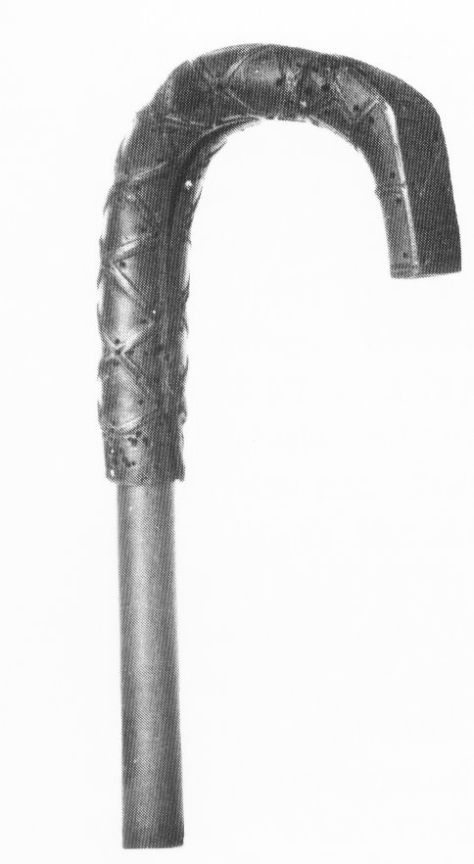

In Glendochart there were five separate hereditary Dewars, each with a separate relic of St. Fillan (the pastoral staff, the bell, the arm bone, the ‘meser’ and the ‘fearg’. Of those relics two have survived until the present day, the Bell and the Crozier. Of the five hereditary Dewars, only one is recognized today, the Dewar of the *Coigreach* or crozier, the Mac-an-deoir. In the 165h century the Mac-an-deoir was a prominent enough person that he was a witness to contracts found in the Bredalbane papers now found in the National Archives of Scotland.

Note the varied spelling of the name. Prior to the advent of dictionaries and “correct spelling” scribes would spell a names by the way it sounded to them.

**John McAne Deor**, Witness 1573 Bond,

CONTRACT between Colene Campbell of Glenurquhay and Dougall M'Dougall of Donnollif, whereby the said Dougall admits that he intromitted with certain cattle belonging to the said Colene's tenants in Bendaraloch in Lome ten years before, and obliges himself and his successors to restore to the saids tenants as many cattle as he shall be proved to have intromitted with, and as sufficient as those he took away, and that before the 24th day of May following; for which the said Colene shall receive the said Dougall into favour, and both parties shall ratify the bond between them, dated 27th March 1567: and farther since both the saids parties claimed right to the Calps of the Clantyre in Lorne they remit the determination thereof to John Campbell of Laweris and Duncane Campbell apparent of Inuerlevir as for the said Colene, and Alexander M'Nauchtane of Doundarraw and Johne Seylach M'Coule in Seill, as for the said Dougall.

Signed at Balloch before witnesses, the said Johne Campbell of Laweris, Duncane Campbell fiar of Glenurquhay, Gregour M'Ean constable of Glenurquhay, **Johne Makindeora in Portbane**, Archibald Campbell in Auchalladour and Gavine Hammiltoun notary,

14th April 1581.

MUTUAL BOND between Duncane Campbell of Glenurquhay and Donald Bobertsoun fiar of Strowan for the protection of their respective lands and tenants; the said Duncane Campbell binding himself to assist the said Donald Robertsoun against all persons excepting only the authority and the Earls of Atholl, and the said Donald Robertsoun binding himself to be a true friend and afald servant to the said Duncane Campbell against all except the authority and the Earls of Argyill, and to cause all the tenants of the lands and barony of Fernay within the Lordship of Descheor and Toyer, serve the Earl of Argyill and the said Duncane Campbell in hosting and hunting according to use and wont;

**Johne Makeandewer in Portbane in Edirgoll**, Gawene Hammiltoun notary, Williame Campbell servant to Johne Campbell of Lawiris witnesses.

At Balloch 20th March 1584

BOND OF FRIENDSHIP between Duncane Campbell of Glenurquhay and Colene Campbell of Craiginche, for the natural blood between them, against all persons, the authority and the Earls of Argile alone excepted; the said Duncane binding himself to defend the said Colene in the possession of his lands of Craiginche, Glenvchie, and Barbrek with the pertinents.

At Balloch before witnesses: **Jhone Makindewar in Portbane in Eddergoll**, John Flemyng in the Port of Lochtay, Robert Meiizeis of Comrie Hew Hay in Skeagis at the east end of Lochtay and Gavine Hammiltoun notary, 8 June 1585.

ALESTER M'RosTiE in Corecharmik makes Duncane Campbell of Glenurquhay and his heirs and Molchallum M'Rostie in Corquhine his sole legatees to all his property; Colene Campbell lawful second son to Johne Campbell of Laweris,

Johne Roy M'Nab in Ardnagalsmoir and **Robert M'Indewar in Finlarg** witnesses.

At Ileanran 15 June 1585.

MARIE NIKVOIREST V'CAUSS in consideration that Duncane Campbell of Glenurquhay is bound to defend her in her actions and quarrels, gives him and his heirs the third part of all her gear; **Johne Makindewar in Portbane**, Maureis M'Nauchtane in Inchadin, **Robert M'Indewar** and Alexander Levingstoun, witnesses.

At Ulanrane 10 July 1585.

BOND OF MANRENT by Alester Stewart in Glenbokie in Buchquhidder, Patrik, Duncane, Robert, James, Johne, and Walter Stewartis his sons, James Stewart in Glenfinglas, Johne, Duncane and Alester Stewartis his sons, Walter Stewart in Balliefoyille and Robert Stewart his son, Johne Dow Stewart son to Patrik Stewart in Dallielaggane [Stewarts of Glenbuckie) to Duncane Campbell of Glenurquhay and his heirs, and that because a certain number of them had upon suddantie slain Johne Makolchalluin Comrie (A. 1559 Balq. Bond) who and his forbears was kynd mynd and servants to the said Duncane Campbell of Glenurquhay and his predecessors; they, being maist willing to repair his honour, bind them severally, to give him and his heirs a free gift of the best audit at the time of their decease, which is called a Calp, besides that due to the Earls of Argyle, and to be true men and servants to him and his against all persons, the authority the Earls of Argyle and the masters of their mailings lands and steadings alone excepted, and to be ready to them in hosting and hunting when required, and to supply reasonable help, according to their power, in any honourable turn tending to the relief of lands or otherwise for the honour of the said Duncane Campbell's house and furtherance of the same:

Evin Dow Campbell of the Likkis, Johne Roy Makinstalker in Cranduycht, Archebald Campbell fiar of Monze, James Campbell apparent of Laweris, Johne Hendrysone, Donald Makrobert in Candroquhat, **Johne Makindewer in Portbane** (witness M’Dougall Contract 1581), Patrik M'Robert V'Laurent in the Port at the east end of Locherne ((1606 Bond), father Robert 1559 Bond) and Donald Maklaurene in Dalbeyich and Finlay Makneill V'Laurent in Auchaliskin in Balquhidder (son of Neill (F) in 1559 Balquhidder Bond), witnesses.

At Illanrane 28 April 1586.

The Black Book of Taymouth contains the following entries:

**JOHNE M'INDEWAR in Portbane** for the benevolence received by him at divers times from the deceased Coline Campbell of Glenurquhay and Sir Duncane Campbell his son, binds him to bequeath to Archibald Campbell his foster, son to the said Sir Duncane and his heirs, the third part, which is his own part, of all his goods, and never to diminish his said goods without the advice of the said Sir Duncane and two of the said **Johne M'Indewar's** special friends, and farther binds himself during the minority of the said Archibald his foster, to furnish him sufficiently in highland clothing and abilyement efferand to the honour of his estate; the said Sir Duncane being bound, on the other hand, to defend him in all his just actions; Johne Campbell in Aucheinch, Thomas Broun, and Patrik Hammiltoun son to Gavine Hammiltoun notary witnesses.

At Finlarg 8 June 1597.

Among the charters of lands, were found some documents of a less common character, and affecting less substantial rights, viz., the privileges attached to the custody of a certain relic of St. Fillan. Fillan, the son of Kentigerna, was of old reverence in the valleys of Breadalbane, and his monastery in Glendochart was still of such consequence in the time of William the Lion, that the Abbot, whether then a churchman or secularized, was named among the magnates of power to support the operation of a particular law beyond the reach of common legal process.

It was a century later that a relic of St. Fillan is said (by Boece) to have been the subject of a notable miracle, which Bruce turned to account for encouraging his soldiers at Bannockburn. The story may be received as evidence of the reverence paid to St. Fillan in the historian's time. That it continued afterwards, we learn from the following documents, though, I fear, they shew that his relics were degraded to the purpose of tracing stolen goods. The particular one which forms the subject of these instruments, the Coygerach, was known within the present generation in the hands of the family of Jore or Dewar, who so early vindicated its possession. It is the head of a staff or crozier of a Bishop or mitred Abbot, of silver gilt, elaborately and elegantly ornamented with a sort of diapered chasing. It is described and figured in the Transactions of the Society of Antiquaries of Scotland, Vol. III., p. 290; and in Dr. Wilson's Archaeology of Scotland, p. G64."

The powerful Abbot of Glendochart, joined in company with the great Earl of Athol of the ancient dynasty, looks like the lord of a secularized Abbacy - the Coarb of St. Fillan - the “successor Sancti Felani" from whom the Dewars had first received the custody of their relic. It is possible that his line continued, though the lordly power and title departed. I wonder that some seanachy has not discovered his descendants in the M'Nabs, (filii Abbatis.) who so long bore sway in the region of St. Fillan; Preface Black Book of Taymouth

His son is possibly **Duncane M’Ane V’yneadar (V’anedeor?,** the deoradh kept the holy relics) alias M’Lauren (28, 1573 Bond)

This story and the accompanying map and photographs are all taken from an issue of The Scots Magazine, published in 1976 and partially repeated in “The House of Dewar 1296-1991” by Peter Beauclerk Dewar. Unfortunately all I have are the pages of the article, which are undated, and I have no idea what the exact month or issue number are. The article is transcribed without alteration. Curiously, though the Dewars are acknowledged to be a sept of the Clan Macnab and believed to be descended from the family of St Fillan, themselves descended from an abbot of Glendochart, Mr. McKerracher made no mention of the Clan Macnab

***The Dewars of St. Fillan*** by A. C. McKerracher

Twelve centuries ago, when Scotland was a dark and pagan land, there came to its shores a missionary from Ireland, known to us as St Fillan. This was no ordinary priest for his mother was Kentigerna, Princess of Leinster, and his father was Feradich, of the noble race of Fitiach Finn.

His saintliness began early, for the legends tell how he was born with a stone in his mouth, and how his disappointed father hurled him into a pool to drown. He was brought safely to the shore by watching angels, and rescued by Bishop Ibar, who fostered him and reared him in the Christian faith. Another legend tells of him plowing with a pair of oxen when a wolf appeared and killed one of them. Fillan knelt in prayer, and the wolf meekly returned and allowed itself to be yoked to the plough.

In time he was ordained as a monk, and accompanied by his mother he crossed from Ireland to Wester Ross around 724 A.D. Here they spread the Word of the Lord until St Fillan decided to carry the faith to West Perthshire, where few missionaries had been before. He and his mother set out together for she had resolved to retire to Inch Cailleach – The Nun's Isle – on Loch Lomond. The journey was long and hard, but eventually they passed through the desolate wilderness that is now Argyll and, assisted by St Fillan's pastoral staff, they climbed to the top of the great watershed near Tyndrum where the waters flow east to the North Sea and west to the Atlantic.

St Fillan sensed this was the place where he should begin his ministry, and a few miles farther on he chose a site for his cell beside the River Dochart, in the glen now called Strathfillan.

Little is known of his work except that he became revered throughout the countryside. More and more of the local people came down from the mountains to be baptized, and his tiny church became renowned as a place of learning. His miracles continued, and there is the story of the lay brother who saw a light shining from the saint's cell one night. He peered through a chink in the wall, and saw the saint writing by means of a brilliant light, which streamed from his upheld left hand. Next day a tame stork plucked out the eye of the prying man, but the saint restored it.

As the years went by St Fillan grew frail. He now walked painfully with his treasured pastoral staff to his preaching seat at Suie, in Glendochart. His life of missionary work in this bleak spot had taken its toll, and it was apparent he was dying. Shortly before his death in 777 A.D. he called to his bedside five of the most faithful lay brothers, and charged them with the keeping for all time of the precious symbols of his work. This they promised to do, and in exchange they were to be given a croft of land, and an annual gift of meal.

These men were called in Gaelic, *Deoradh*, a word originally meaning "stranger" or "wanderer," probably because they often carried the saint's relies far a field for special purposes. Later, the meaning of the word altered to "custodian," and the Gaelic word itself became modified into the modern surname of Dewar.

The relics they guarded were St Fillan's Quigrich, or pastoral staff; the Bernane, or Chapel Bell and the Fergy, the Mayne, and the Meser. What the last three were is now conjecture, but it is suggested that the Fergy was the saint's portable altar, the Mayne was his arm bone from which the miraculous light had come, and the Meser was the manuscript he was writing.

By the 12th century the saint's original cell had been enlarged into a small church the size of the present ruins, and had an abbot in charge. A sizeable monkish community existed here, and evidence of their life can be seen. A short distance to the north is the Priests' Well, still enclosed by stonework, and about two hundred yards east of Kirkton Farmhouse are the remains of a rectangular wall enclosing the monks' garden. To the north of the church is a very old graveyard evidence that a much older building stood on this site, for in Roman Catholic times that side was reserved for the Evil One, and suicides.

As the old Celtic Church was absorbed by the influence of Rome, more and more land was removed from St Fillan's chapel to other dioceses, and its influence waned. An abbot still presided over it, and sanctuary was still provided for hunted men. The fugitive King Robert the Bruce came here in I306, shortly after his coronation and his tiny band rested under the thatched roof. To their Ard-Righ came the Dewars of the Quigrich and the Mayne, and gave him the Gaelic blessing of St Fillan, much to the annoyance of the abbot and Bishop Moray who frowned upon this Celtic ritual. The blessing of the Old Church proved highly efficacious for, shortly after leaving; the King's party was attacked by the McDougall’s of Lorn, at nearby Dal Righ, and had a miraculous escape.

Both these Dewars were at the Battle of Bannockburn, and Boece relates that on the eve of battle the King knelt in prayer before the casket containing the Mayne. Suddenly there was a click and the case opened. The terrified Dewar looked inside, and whispered, “Here is a great miracle." He confessed to the King that he had left the relic behind in case it was lost, and now the saint's arm bone had miraculously appeared. Fortified by this sign of divine approval, King Robert went on to win one of history's greatest victories.

The grateful monarch later made many gifts to the church in Strathfillan, and had it created into a priory, confirmed by Pope Clement VI in I348.

The Dewars of St Fillan are mentioned in many old records but, of course, always as a description of the persons; surnames as such only came into use in the I7th and I8th century. The earliest account is a missive dated 1336 from Alexander Menzies, Lord of Glendochart, to “Donald McSobrell, Dewar Cogerach," confirming him in the lands of Ewich in Strathfillan, and free from all taxes.

In 1428 an inquest was held before a jury by the Baillie of Glendochart to establish what were attached to the custodian of the Quigrich. They found that “Finlay Jore (Doire or Dewar) should have for all time half a boil of meal from every inhabitant of Glendochart holding more than a half merkland of ground." These rights were confirmed in 1487 by Royal Charter of James III in favor of one Malise Doir, and possibly the then custodian felt the necessity for this as the Church was casting covetous eyes at his possession.

The prior of Strathfillan, Hew Currie, tried to obtain a decree in I549 to compel, "Malise Doir of Quigrich, Archibald Doir of FeIgy and Malcolm Doir of Bernane to deliver and present in the kirkis of Stráphillan certain reliques, and nocht to be taken furth agane without the licence of the said prioure." Failing this the Dewars were to be excommunicated.

However, the Lords of the Council found in favor of the hereditary custodians, and absolved them from any punishment. Holy Church decided to seek revenge in other ways, and in 1551 Queen Mary issued an order assessing for tax, "Malise Dewar, the forty shilling land of Ewich ... which have never been computed in any rental."

Apparently at this time the five hereditary Dewars still held the land granted to them eight centuries before. Malise, Dewar Quigrich had his croft at Ewich, near St Fillan's church; the Dewar Bernane's croft was at Suie in Glendochart; the Dewar Fergy's croft was at Auchlyne, where the ruined Chapel Na Farig; and the Dewar Meser stands was at Killin.[12]

The Dewars were regarded as the leading families in Strathfillan and Glendochart, and were a source of irritation to the established church for the local people still used the relics in healing rituals which went back to pre-Christian times. However, the effect of land taxes, and the coming of the Reformation, eventually drove the Dewars from their lands. The line of Dewars of the Fergy, the Mayne and Meser died out, and their relics were probably destroyed by zealous Reformers.

By the early I7th century the line of Dewar Bernane also failed, and St Fillan's bell was removed to the graveyard of Strathfillan church. Here it sat on top of a flat tombstone, supposedly the Saint's grave, exposed to the elements. The local people, who regarded it with superstitious awe, venerated it and the bell became the centerpiece of one of the strangest ceremonies ever enacted in the Highlands.

A mile upstream from the ruined priory lays the Holy Pool, overlooked by a hillock with three cairns on top. People flocked here from miles around to bathe in the water, which was supposed to cure all ailments. After immersion, each person picked up nine stones from the riverbed and climbed to the Cairns. Then they walked round each one three times depositing a stone at every turn, and finally flung on to the cairns the part of their clothing which covered the afflicted spot. An English visitor to Tyndrum in 1798 noted this curious healing ceremony, and recorded the cure for madness. The insane were put through the ritual in the pool, then carried to the priory and tied to a wooden framework. This was lowered until the patient had his head inside the old baptismal font, which now lies in a corner of the ruins, and the Bernane Bell was placed on top. Straw was then piled over the afflicted person, and he was left for the night. Next day his relatives returned, and anxiously tested the ropes, for if they were loose a full recovery had taken place. Strangely enough, at one of the last such ceremonies around 1850 the local minister recorded that a chronically mad person was returned to sanity.

However, this last cure was without the aid of the bell for an English tourist heard of the bell's reputation for always returning to Strathfillan, and took it back with him to Hertfordshire to test this property, despite the pleas of an old woman who tried to stop him. The Bernane's homing instincts obviously did not work on foreign soil, for it remained in England for the next seventy years until a chance conversation between Bishop Forbes of Brechin and another guest at a country house in 1869. The stranger informed the Bishop that a relative held St Fillan's bell, and immediate steps were taken for its recovery.

The relic is now on display in the National Museum of Antiquities of Scotland, in Edinburgh, where it can be seen to be an excellent example of a Celtic bronze bell, cast in one piece, and having the traditional wide mouth.

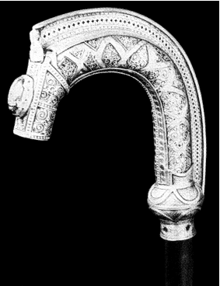However unusual the story of St Fillan's bell, that of his Quigrich, or pastoral staff, is even more remarkable.

At the time of the Reformation most of the Dewars were forced from their ancestral crofts with the exception of the Dewar Quigrich who remained until I574. In that year, in a Charter of James VI, there is confirmation of the sale of the lands of Ewich from Donald Macindeara vie Cogerach, or Donald, son of the Dewar, to Sir Duncan Campbell of Glenorchy. From that time the fortunes of the Dewars Quigrich began to wane. Around 1660 they sold the Quigrich to the Catholic McDonnell’s of Glengarry, who were delighted with such a relic. The sale only increased the Dewars' misfortune, and they never rested until they had repurchased the staff. A later Dewar confirmed his right of possession at the Court of Session in 1734, and lodged with his appeal the well-preserved letter his ancestor had received from James III.

Ill luck still followed the Dewars Quigrich, and in 1782 they were represented by Malise Dewar, a day laborer, who resided with his consumptive eldest son in a mean cottage in Grey Street, Killin. It was here that William Thompson, an Oxford graduate, saw the Quigrich and he wrote to the Earl of Buchan, president of the newly formed Society of Antiquaries of Scotland, suggesting they should purchase the staff. Unfortunately, the letter was overlooked and no action taken. A French tourist in 1795 was astonished to find that Presbyterians still traveled over a hundred miles to drink healing water that had been passed through the inside of the crozier. After the death of Malise and his consumptive son, the relic passed to the younger brother, Alexander, who took it to Edinburgh in I808, and advertised in the *Caledonian Mercury* that "there is to be seen at the first entry below Covenant Close a most curious antiquity, in the family of the proprietor since before the time of Robert the Bruce. Admittance two shillings."

From this unscrupulous custodian the Quigrich passed to his son, Archibald, who had a farm in Balquhidder, and then Glenartney. Along with thousands of other farmers he was ruined in the agricultural depression that followed the Napoleonic Wars, and petitioned the Government for free passage and free land in Canada. He left Scotland in 1818, taking with him the treasured Quigrich, and settled in Beckwith, Ontario. His son, Alexander, followed him, but could not settle in this new country despite the fact that all around were Gaelic speaking Perthshire Highlanders.

Eventually, he came to like his adopted country, married a Scots girl, and moved to the township of Plympton, Ontario, in I850, taking with him the Quigrich, which he had inherited. Here he prospered, and raised a large family. Once again the Dewar Quigrich became a greatly respected person, and many Canadian Highlanders came to his farm seeking water passed through the staff to give to an ailing animal.

About this time a Scots Canadian priest, the Rev. Eneas McDonnell, a descendant of the McDonnell’s of Glengarry who had bought the Quigrich in the I7th century, discovered the saint's relic was held in a remote farmhouse on the Canadian prairies. He wrote to Dr Daniel Wilson, secretary of the Society of Antiquaries, and several attempts were made to buy the crozier. The Earl of Elgin, senior member of the Bruce family, offered £400 in 1859, but Alexander Dewar always refused.

Chance took Dr Wilson to a post at Toronto University, and he established contact with the Dewar in I870 The hereditary custodian was now 87, and worried that his sons would not have the same interest in preserving the saint's staff. He agreed to part with it for 700 dollars of which 200 dollars was to be his donation towards the acquisition. In 1876 Alexander Dewar, with the consent of his son Archibald, executed a deed of transfer to the Society, and gave the Quigrich "on trust to deposit the same in the National Museum of Antiquities in Edinburgh, there to remain for all time to come for the use, benefit and enjoyment of the Scottish nation." However, the hereditary title of Dewar Quigrich was to remain with the family to avoid any bad luck.

When the Quigrich was examined on its arrival in Edinburgh it was found to be a nine-inch high head of a pastoral staff. The casing is of silver gilt with patterns of filigree around silver plaques. At the crook end is a small carved bust and inset charm stone, and the superb workmanship is of I4th century origin. There was consider able puzzlement why some of the filigree appeared older than the rest, but when the outer casing was removed a much older crozier of the 9th century was found inside. Although the wood has long since disappeared, the bronze covering remains, and it was obvious this original staff had been stripped of all its ornamentation to decorate the outer casing.

In the days when St Fillan used it as he spread the Word of God around the lonely glens it would have been a staff of rare and wonderful beauty.

Now this ancient relic of one of Scotland's most revered saints lies safely on display in the museum in Queen Street, Edinburgh. Those who pause and admire its splendor should also remember the fidelity and devotion of the long line of Dewars Quigrich who, down through twelve hundred years, faithfully carried out their promise to St Fillan.

Grey Street, Killin, from across the Falls of Dochart.

Here lived Malise, Dewar Quigrich, towards the end of the 18th century,

Photo by A. C. McKerracher

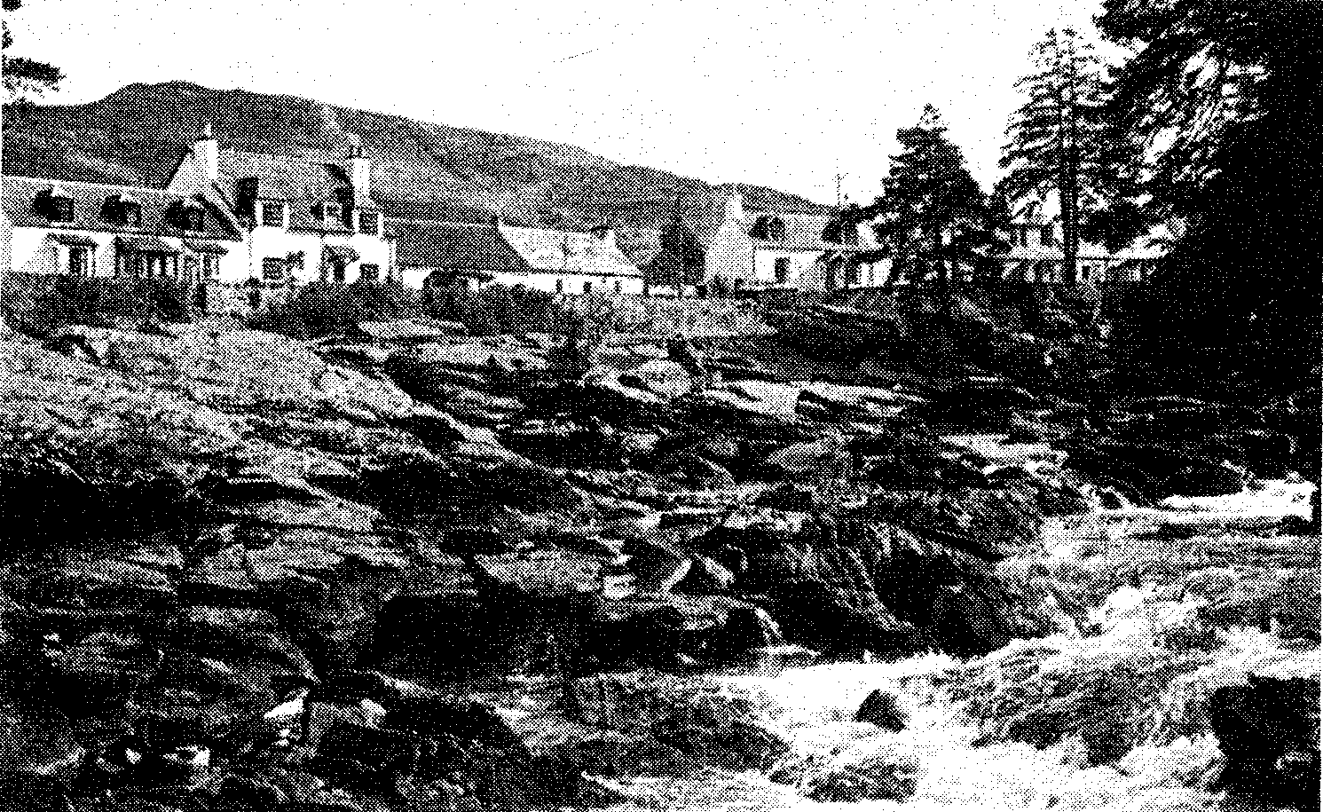

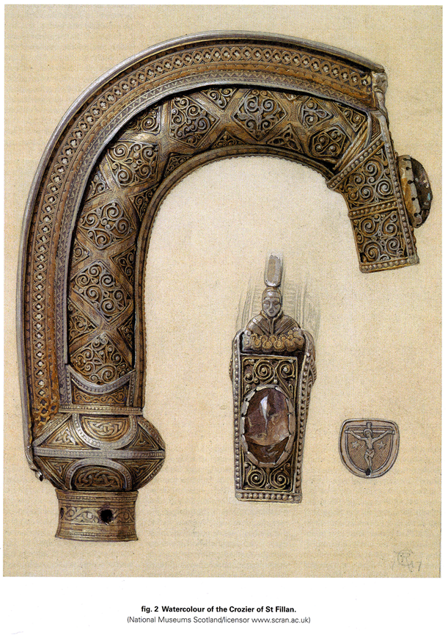The following article was in the Clan MacNab Society Newsletter for 1982, and was written by James Charles Macnab of Macnab the 23rd Chief. It is presented as written.

**ST FILLAN - THE MACNABS - THE DEWARS:**

Some of you may have read Tom Weir's article "Old Ways - New Ways" in the November '82 edition of the Scots magazine. In the January '83 edition, a letter was published from Thomas D. Dewar (The Dewar Na Bernan) in which he sets out the relics of St. Fillan and mentions that the Dewar, who looked after The Coigerach, or Crozier, had a croft known as Croitendeor. This croft is shown on the map of Kinnell Estate produced when Archibald sold the estate in the early 1800's. It is a piece of ground running up the hill to the south of the War Memorial in Killin.

Thomas Dewar goes on to say in his letter: "Frequent references to the MacNab's as heirs of St. Fillan and of the Abbot of Glendochart are erroneous, without foundation and contrary to historical evidence, the Dewar Coigerach, Coarb of St. Fillan being recognized officially by the Lord Lyon in these offices."

Thomas Dewar has been making this sort of statements for some time and recently the Secretary referred the letter to the Lord Lyon, King of Arms. In his reply the Lyon quotes a letter he wrote to a Mr. A. B. T. Dewar on this subject, as follows "With regard to the question of the hereditary abbot of Glendochart, I am afraid that I am not at all satisfied about the succession to this office. It seems to me that very little is known about it. It also seems that much of the more recent scholarship points to the fact that the Dewar Coigerach or Dewar Quigrich was a separate office from that of hereditary Abbot of Glendochart. There is an interesting article that I suggest you read entitled "The Toschederach" by the late Professor W. Croft Dickinson in the Juridical Review, LIII at page 85. From this article it would appear that the Dewar received certain dues from the tenants of Glendochart and had a duty to seek goods and cattle stolen; from Glendochart and it seems that when his services were called upon he was to be given four pence or a pair of shoes and victuals sufficient for the first night. These arrangements were remarkably similar to those made for sergeants of the peace. It would appear from this that the Dewar was an officer and not necessarily the hereditary Abbot. I cannot see that being receiving four pence or a pair of shoes or victuals for the night for performing certain services would be appropriate for a hereditary Abbot.

We know that his custody of the Staff involved him in assessing whether people were telling the truth or not by-taking the oath, etc., with a hand over the relic. We also find Croft Dickinson stating "The relic keeper, the Dewar, still exercises the office as an officer or Sergeant within the feudal system, when his superior the Toisech had disappeared.” It may be that the Abbot of Glendochart was in effect the Toisech and the Dewar his officer and again at page 107 Croft Dickinson states "But such an interpretation would explain for example, why the duty of seeking stolen goods and cattle in Glendochart fell to the keeper of the Quigrich of St. Fillan when apparently the Abbot of Glendochart would be the officer ultimately responsible. As you can see, the scholarship of this century was tending toward the opinion that the position of Abbot of Glendochart and that of Dewar or Dewars; were separate.

In these circumstances I think you might agree that it would be quite inappropriate for me to attempt to maintain that you are the hereditary Abbot of' Glendochart. As Croft Dickinson states at page 108 "With the development of the feudal system; and with the growing uniformity in administration, old offices gave way to or were reconciled with the new,” It seems that the office of hereditary Dewar has survived but it may be that the office of Abbot of Glendochart has not survived."

The Lyon also mentions that the late: Professor C.G. Coulton commented on Coarbship in his "Abbeys and Social Life in Scotland" published earlier this century. He concludes with the following:

"With regard to the Armorial Bearings these were recorded in the Public Register of all Arms and Bearings in Scotland in name of Robert St. Fillin Dewar (Volume 28, Folio 78) in 1930 and were matriculated in the name of Thomas Douglas Battersby Rutherford Dewar in the said Public Register (Volume 66, Folio 34) on 28 May 1982. These Arms at present may only be used by the said Thomas Douglas Battersby Rutherford Dewar."

The bronze 8th century Bernane Bell, held by its hereditary Dewars until the 17th century and used in the healing ceremony in St. Fillan’s chapel.



Now in the National Museum of Antiquities, Edinburgh

Photo by the National Museum of Antiquities

Background: From "Rob Roy Macgregor, his life and times" by WH Murray, published by Canongate Books.

At this period Rob Roy was living under the protection of Ian Glas (Grey John Campbell), the earl of Breadalbane who had given Rob the lease of a house and land at Auchinchisallen in Glen Dochart about five miles east of Crianlarch. But he was still his own man:

P. 167

"Rob went his own way. He could stand up to Breadalbane or Argyll no less than Montrose. On one occasion, Ian Glas had employed as land agent a gentleman of Argyll's family, and given him more authority than his due. This man evicted a family of Clan Gregor from its smallholding in Glen Dochart, allegedly for insufficient cause and its seemingly easy prey as one of a broken clan. The property and stock had been taken when Rob Roy on appeal had the agent seized and brought before him at Tyndrum. He obliged the man to sign papers restoring the property and reinstating the clansman, and then had him ducked in the pool of St Fillan, midway between Tyndrum and Crianlarich. A chapel stood there by the river Fillan. The holy waters were believed to cure lunacy and other disorders - numerous cairns around were covered with the rags of bathers' clothing. The Campbell agent was given the cure, which included roping him overnight to a wooden frame with St Fillan's bell set on the crown of his head. The incident gave affront to Argyll as well as Breadalbane. Perhaps to give them time to cool, Rob Roy removed for a while to Craigrostan, but more likely to organize his Martinmas raids on Menteith."

Grahame Wilson touches the Healing Stones, blessed by St Fillan for the healing of bodily ailments, with articles of clothing sent by post by sick people. The mill where the Stones are kept has been in the Wilson family for three generations. Every Christmas villager’s culled straw and twigs from the wash of the River Dochart “for bedding the Stones”

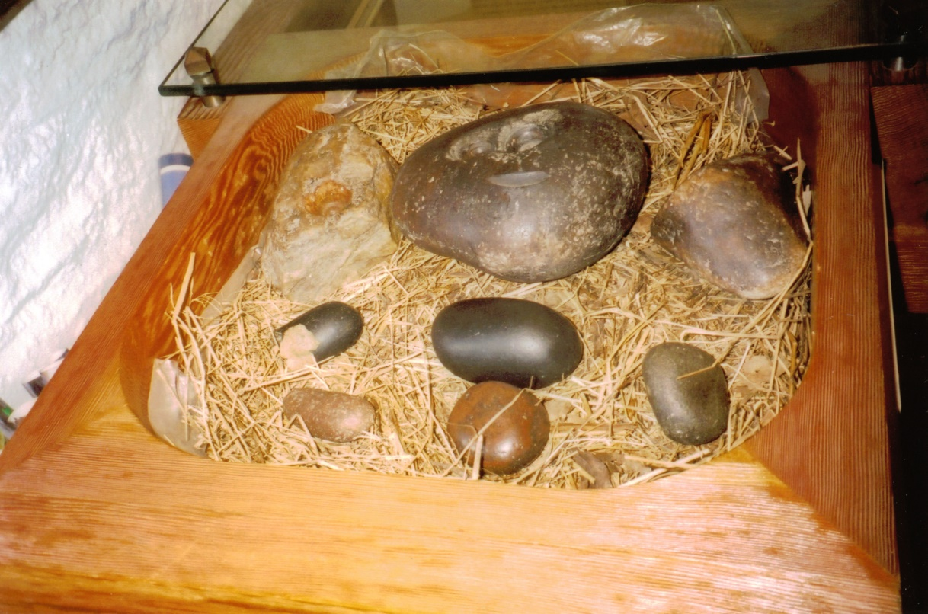Note: The mill is now the Killin Visitor Center. Below the stones as kept today. The BW photos were scanned from the Scottish Field issue of June 1973

Color picture contributed by Betty Wilson

Seventy-year-old Jimmy Anderson, session clerk of Killin Church, shows the stone under which the Ossianic hero, Fingal, is said to be buried

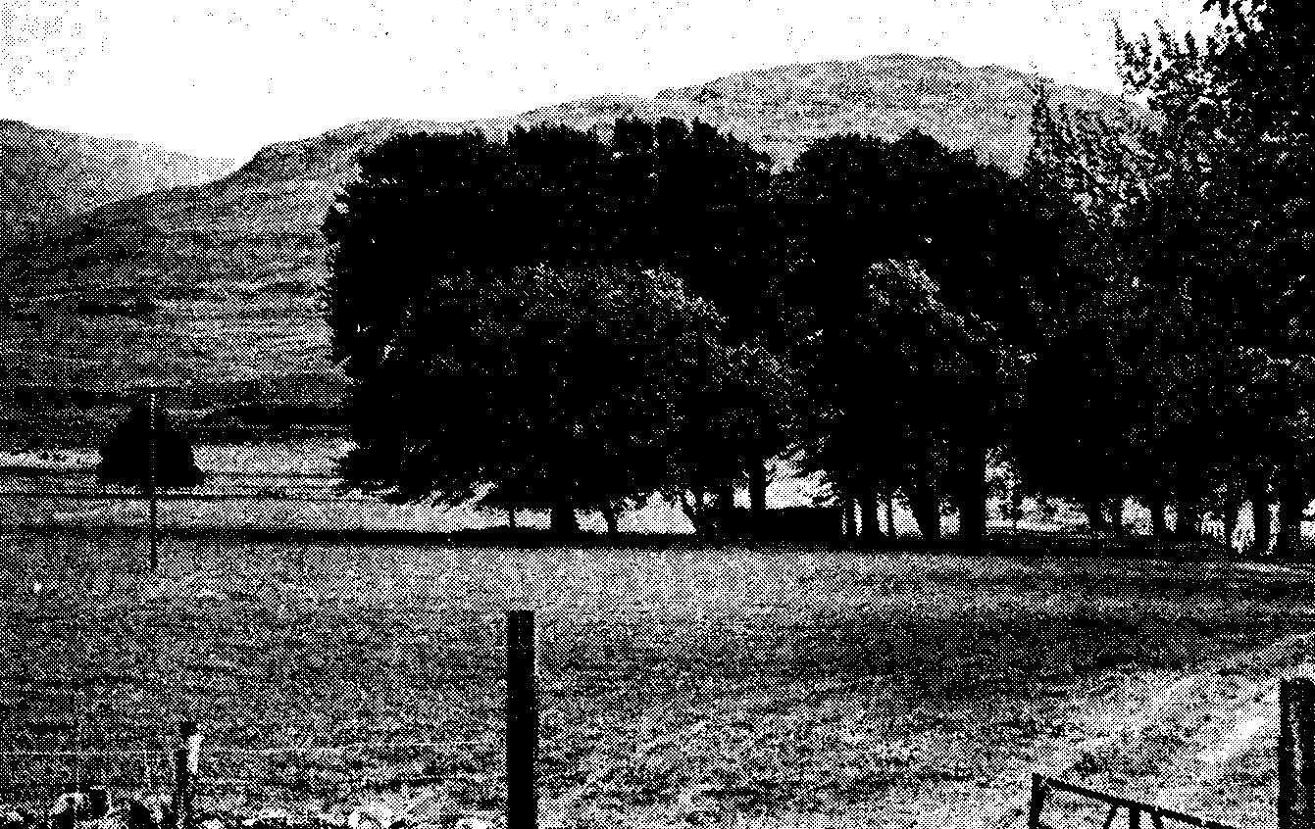

The ruined Chapel Na Farig at Auchlyne where the lost relic of St. Fillan called the Fergy was kept

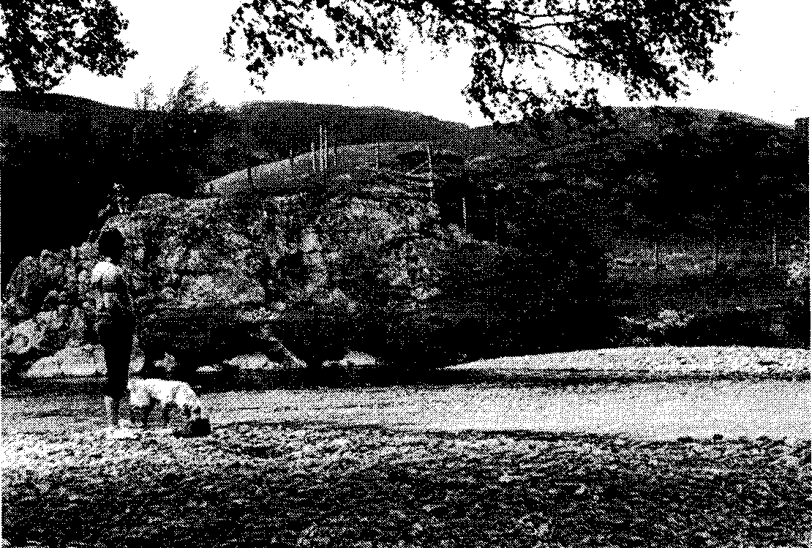Photo by A. C. McKerracher

The Holy Pool on the River Dochart. It lies a mile up stream from the ruined priory, built on the site of St. Fillan’s cell.

On the hillside above stood the three cairns used in the healing ritual.

They were removed sometime prior to 1975 during road improvements

by A. C. McKerracher

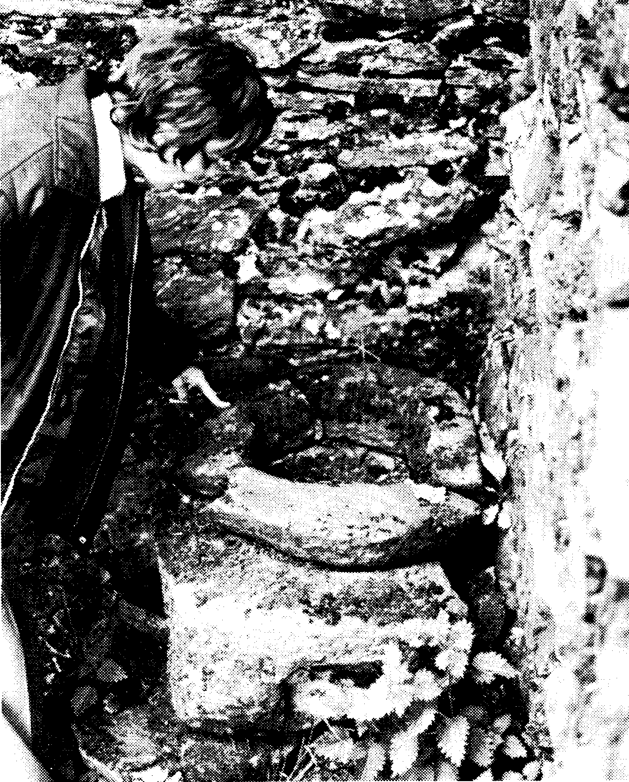

The baptismal font, probably used by St. Fillan, much later it was used in a ceremony for the treatment of madness. It lies in a corner of the ruins of the priory built on the site of St. Fillan’s cell

Photo by A. C. McKerracher

The following stories and pictures came from web pages at **Perthshire Diary – A daily dose of Perthshire and Scottish History**.

http://www.perthshirediary.com/ Perthshire Diary features a different story and picture for each day of the year.

The picture at right is of the river Dochart in winter.

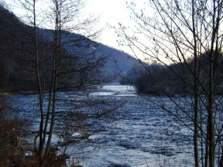**The Quigrich of St Fillan**

St Fillan came originally from Ireland and arrived at Glendochart around 730 AD. He built a priory near Auchtertyre in Strathfillan. Little is known of his work in Glendochart though he was certainly held in great veneration and summer and winter feasts were held each year in Killin in his honor. When the saint died he left certain relics which, rather unusually, were entrusted not to the monks of his priory but to the custody of laymen living in Glendochart who were given a free grant of land by the king in virtue of their office.

Such men were called deoradh, which is Gaelic for stranger. This referred to the fact that the relics were often carried as a ‘stranger’ to other areas as they were considered to possess special powers. The relics of St Fillan were handed down from father to son and in the course of time the families entrusted with the relics were given the surname deoradh or Dewar.

Perhaps the most important relic of all was the quigrich or the pastoral staff of St Fillan. This was often taken to distant places where it was considered to have magical properties in the recovery of stolen goods. The fact that the family having custody of the quigrich should possess such a potent relic was not popular with the Priors of Strathfillan and in 1549 there was an attempt to compel *“Malise Doir of Quigrich to deliver and present to the kirkis of Strathphillan certain reliques, and nocht to be taken furth agane without the licence of the said prioure.”* Failure to agree was to lead to excommunication. However the Lords of the Council threw out the decree and Malise Doir retained the relic.

The quigrich stayed with the same family in Glendochart for about 900 years, when, because they had fallen on bad times, they sold it to the McDonnells of Glengarry. This breach of trust brought them nothing but trouble and eventually with some difficulty they were able to buy it back. Though it was no longer used to locate stolen property it was believed that water in which the staff had been dipped was most efficacious in curing sick cattle.

No charges were made for this service but the realization seems to have dawned on the Dewar family that possession of the quigrich did confer certain financial advantages. They found that tourists in Killin were prepared to reward them for a view of the relic. In 1808 Alexander Dewar even took it to Edinburgh where according to the Caledonian Mercury “there is to be seen at the first entry below Covenant Close a most curious antiquity, in the family of the proprietor since before the time of Robert the Bruce, admittance two shillings.”

Eventually the quigrich passed to Archibald Dewar who in 1818 emigrated from Scotland to Canada taking the crosier with him. That might have been the end of the story had it not been for the efforts of the Rev Eneas McDonnell, a catholic priest in Canada and a descendent of the McDonnells of Glengarry who had possessed the quigrich for a short time. He wrote to Dr Wilson who was secretary of the Society of Antiquaries of Scotland and between them efforts were made to secure the return of the staff to Scotland, but without success.

There was to be yet another twist to the story. Dr Wilson was appointed to a chair in the University of Toronto and was able to visit Alexander Dewar, son of Archibald, who now owned the quigrich. By this time Alexander was almost ninety years old and was worried that his own sons would not show the same interest as he had done in preserving St Fillan’s staff. He agreed to part with the staff and on December 30th, a deed was drawn up to surrender the quigrich to the Society of Antiquaries of Scotland *“there to remain in all time to come for the use, benefit and enjoyment of the Scottish Nation.”*

The Quigrich was placed and may still be seen in the National Museum of Antiquities in Edinburgh

**St Fillan's Bell**

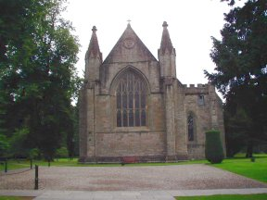Like the Quigrich, the St Fillans bell was also placed in the safekeeping of a Dewar whose land was at Suie in Glendochart.

It was evidently considered to be a relic of some importance and was borne in the pageant at the coronation of James 4th in 1488.

Sometime after the Reformation, the Dewars of Suie lost possession of the Bell, which made its way to the churchyard at Strathfillan (see picture above). It was still considered to have magical properties, and was much used in rites to cure the insane. (It would be interesting to know the success rate of these cures which consisted firstly of immersing the insane person in the Linne Naomh or Holy Pool at Strathfillan; then taking them to the churchyard at St Fillan where they were secured to a stone in the churchyard with the Bell placed over their heads and left overnight. If by morning they had broken loose from their bonds it was a sign that they would be cured. If they were unsuccessful it was considered that there was no hope of curing them.)

There was another tradition concerning the Bell. That if it was to be removed from the churchyard it would return there by the next day. In 1798 a somewhat skeptical Englishman decided to test out the theory and removed the Bell to England.

There it remained for over seventy years when Bishop Forbes of Brechin, while on a visit to the Earl of Crawford, happened to meet an Englishman who in conversation mentioned that a relative of his living in Hertfordshire still possessed the Bell.

The original thief who kept a diary of his Scottish visit related the circumstances with some panache. “In order to ascertain the truth of St Fillan’s Bell I carried it off with me to England……An old woman asked what I wanted with the Bell and I told her that I had an unfortunate relative at home out of his mind and that I wanted him cured. ‘Oh but,’ she says ‘you must bring him here to be cured or it will be of no use.’ Upon which I told her that he was too ill to be moved and off I galloped with the Bell to Tyndrum Inn.”

Once again a relic of St Fillan, which had appeared to be lost, forever was returned to Scotland and now stands beside the Quigrich at the National Museum of Antiquities in Edinburgh.

One does not have to be a catholic or even a Christian to feel that there is something wonderful about the way in which these two relics returned, if not to Strathfillan, at least back to the capital of Scotland *“for the benefit and enjoyment of the Scottish Nation.”*

Bruce's secret protector

After the battle of Methven in 1306 in which Bruce and his followers were defeated by an English force under the Earl of Pembroke, he retreated to the hills and remained for a time in Glen Dochart.

Here he became acquainted with the traditions of St Fillan and worshipped at his shrine. McDougall of Lorne pursued the Bruce with a force of 1,000 men. Although heavily outnumbered, Bruce and his followers were able to escape from his enemies with almost no loss of life and it was believed that this miraculous deliverance was due to the protection of St Fillan.

It was natural, therefore, that eight years later, before the battle of Bannockburn, Bruce should pray to St Fillan for help and protection. He believed that one of the relics of St Fillan had been brought to his tent for this purpose. This was the left arm of the saint, enclosed in a silver case, and was known as the Mayne. Suddenly, as he was praying, so the story goes, there was a loud crack from the case. A priest went to the alter and opened the case. *“This is a miracle,”* he cried, *“I brought the case here empty lest the Mayne be lost in the confusion of battle. Yet here it is, back in its case for all to see.”*

Bruce accepted this as an omen of success and was not disappointed next day.

As late as 1670 there was mention of a Dewar’s croft at Killin known as Dewar-na-Maynes croft. Whether the Mayne was still at Killin in 1670 is not known. Certainly no one has any knowledge of its whereabouts today.

**The birth of Dewars Whiskey**

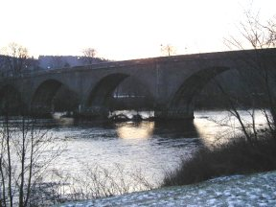John Dewar was born in 1806 at the small farm of Shernavil near Aberfeldy. When he left school he served as an apprentice to his elder brother who had a joiner’s business in Aberfeldy. It was when he was aged twenty-two that he received an invitation from James Macdonald, a distant cousin, who had a wine merchant’s business in Perth close to the Fair Maid’s House. John liked Perth, liked the job he was in, got married and eight years later was made a partner in the firm. But he was an ambitious man and at the age of forty he set up his own shop in the High Street of Perth.

Even in 1846 there was still plenty of illicit whisky produced in the Highlands though with the Act of 1823, which reduced the duty on whisky to 2s 3d per gallon, more and more legal distilleries were set up. The whisky industry, which meant the production of malt whisky, was still a small affair and nearly all the spirit was drunk within the confines of Scotland. John Dewar’s ambitions were relatively modest to begin with and for the first ten years his market was confined to Perth and the surrounding area. He made one important innovation, he started to bottle his whisky and found by these means that not only was he able to sell more locally but was also able to tackle markets further a field.

The malt whisky produced at this time varied considerably in age and palatability and was not therefore a particularly popular drink in England. It was the discoveries of the virtues of blended whisky, a mixture of malts and grain whisky that opened up the English market.

John Dewar died before he was able to capitalize on this innovation and it was left to his two sons John and Tommy to create a whisky known throughout the world. To them may be added Alexander Cameron, a man who revolutionized the art of blending and who was responsible for the final blend of Dewar’s whisky, which today contains around forty separate whiskies.

Tommy was the salesman and traveled all over the world promoting the product. He remained a bachelor, became Baron Dewar and made his home in Sussex. He donated Kinnoull Hill to the people of Perth. John remained in Scotland, was made Baron Forteviot and always retained an intense interest in the affairs of Perth. He worked as a County Councilor and later became MP for Perth and East Perth. He died November 23rd 1929.

Note: The picture below is of the bridge over the Dochart at Killin that also crosses over the island of Inchbuie the traditional burial place of the Macnabs

The House of Dewar 1296-1991, The Fortunes of Clan Dewar by Peter Beauclerk Dewar

With a foreword by the Rt. Hon. The Earl of Erroll

Published in 1991 by Peter Beauclerk Dewar, 45 Airedale Avenue, Chiswick, London, W4 2NW

Distributed by Philimore and Co. Ltd. Chichester, West Sussex

This book begins with a frontispiece illustration of the Letters Patent confirming Lieutenant Colonel Kenneth Malcolm Joseph Dewar of that Ilk and Vogrie of Grayshott, Surrey as The Dewar and Chief of the Name and Arms of Dewar, as Representer of the Dewars of that Ilk and of the Baronial House of Dewar of Vogrie who was also admitted to the Standing Council of Scottish Chiefs as chief of the Clan Dewar.

The book then describes the history and genealogy of The Dewars of that Ilk who originated at a place called Dewar Farm somewhat south of Dalkeithand Edinburgh. From there the family acquired and moved to the estate of Vogrie, just south and east of Dalkeith.

These Dewars have no connection to the better known Dewars of St. Fillan, who are then described in short sketches, followed by a chapter on the better known family of John Dewar and Sons Ltd Distillers who have been ennobled as The Lords Forteviot.

Next is a chapter on the Dewars of Doles, a cadet house of the Dewars of Vogrie, followed by a chapter on the Dewars of Lassodie who are unrelated to either the Dewars of Vogrie or of St. Fillan.

The book finishes with a chapter on Dewar Scientists, including Sir James Dewar, inventor of the Dewar Flask, Dewars of Jamaica and the West Indies, the family bearing the name Dewar-Duries and a final chapter titled prominent Dewars (Living and Dead).

The appendix contains black and white illustrations of different Dewar coats of arms with names of the persons to whom they were awarded and descriptions of the arms themselves.

Although the Lord Lyon has accepted Dewar as a Clan with arms and a banner, there is no mention of a tartan other than the one created for Dewar’s Whisky (green black and yellow based on the MacNab) and that one is registered as a corporate tartan, not a clan or family tartan.

The author closess his introduction with the following: “It is hoped that we shall soon be able to establish an Association of Dewars so as to pool and disseminate knowledge gained about the Dewars, and we plan to write to all Dewars who responded to the circulation of this book inviting them to join in due course. He then give contact information c/o Lloyds Bank Plc, Law Courts Branch, 222 Strand, London WC2R 1BB

1. Yet, the fighting men of Clan Macnab were on the other side of this battle. Allied by marriage with the Bruce’s bitterest enemies the McDougall’s of Lorn and the Coymns, the Macnab’s were present, with other Scots who were allies of the English, though there is no mention of their ever being involved in the fighting.
2. Reportedly the Abbot feared its loss if the Bruce were defeated in the battle.
3. A “boll” is a traditional Scottish dry measure equivalent to 3 bushels 3 pecks or 1.944 gallons http://www.scan.org.uk/measures/capacity.asp
4. *Merkland* refers to the value of a piece of land. In England the “mark” was never a coin, but a money of account only and apparently came into use in the 10th century through the Danes. It first was taken as equal to 100 pennies, but after the Norman Conquest was equal to 160 pennies (20 pennies to the oz.) = two thirds of the pound sterling, or 3s. 4d. and therefore in Scotland 13 ½d English; the mark (merk) Scots was a silver coin of this value, issued first in 1570 and afterwards in 1663. *Encyclopedia Britannica*, 14th edition, 1929.
5. Another spelling is *Quigrich* and on the map of Glen Dochart can be found Dewar Quigrich’s Croft, between Tyndrum and Crianlarich near St. Fillian’s Priory.
6. Toft, a Scandinavian word meaning an enclosed field near a house or a house and homestead. *The New Webster* Encyclopedic *Dictionary of the English Language*
7. On the map of Glen Dochart, Dewar Bernane’s Croft is shown on the south bank of the river Dochart near Inneshewan.
8. Croft, a smallholding of land. The Crofters’ Holdings (Scotland) act 1880, defines a crofter as the tenant of a holding who resides on his holding, the annual rent of which does not exceed £30 in money and which is situated in a crofting parish. The Old English word, meaning originally an enclosed field, seems to correspond to the Dutch *kroft*, a field on high ground or downs. The ultimate origin is unknown. *Encyclopedia Britannica*, 14th edition, 1929.
9. Dewar Meser’s Croft is shown on the map of Glen Dochart just south of Kinnell House.
10. A good story, however, it is more likely that he was actually holding a tiny clay lamp in his hand. The lamp would have had a bit of dried moss for a wick and was fueled by butter or oil. It would not have needed to light the room but just a small area of the manuscript
11. Crozier or Pastoral Staff, a crook-headed staff conferred on bishops at consecration and on mired abbots at investiture; probably derived from the Ilituus of the Roman augurs, and so called from Old French crocier, Medieval Latin crociarius, crook-bearer. The “crook” was formerly called “crozier’s staff,” afterwards abridged to “cozier” (see. T. Taylor in Archaeologic, lii.) *Encyclopedia Britannica*, 14th edition, 1929.
12. See the included Map of Glen Dochart, which has the locations of the Dewar’s Crofts located on it.