Coat of Arms:
Sable, on a chevron argent, three crescents vert,, in base an open boat with oars argent sailing in a sea proper.
Crest: The head of a savage affronte proper.
Supporters: Two dragons sable, armed and langued Or, having wings elevated Argent Semee of crescents vert.
Motto: “Timor omnis abesto” (Be all fear absent).
Plant Badge: Stone Bramble
Slogan: Bovain
Lyon Register, I, 229; XL

In English: A black (shield), on which is a silver chevron containing three green crescents. In the base of the shield is shown an open boat with silver oars sailing on a sea rendered natural. Note: there are two men shown in the boat and each should be handling a pair of oars unlike the single pair shown. This refers to the sons of the chief taking their boat to Nish Island in pursuit of the Macnishes.
The crest is the head of a savage facing front, rendered natural. This is generally understood to represent the head of the MacNish, which was cut off and brought back to the Chief by his sons, after the massacre on Nish Island. Note: this is not unique to the Clan Macnab at least one other clan uses a head as it’s crest.
The supporters are two black dragons, with claws and tongues (armed and langued) of gold, with erect wings of silver. On each wing are three more green crescents. The origins of the dragons are unknown and it is not known what they signify. Some illustrations of the coat of arms show a pair of highlanders as supporters, however, this is incorrect.
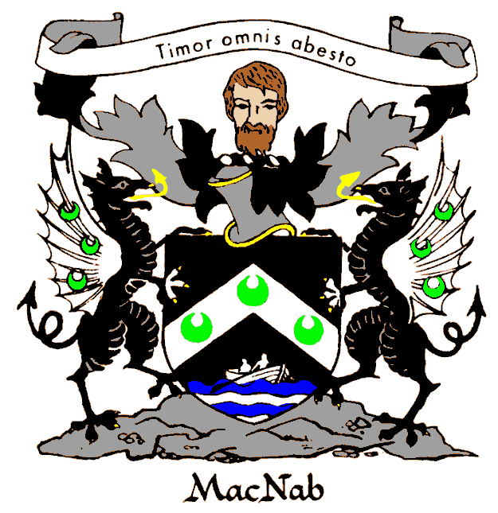
The motto, sometimes translated as Dreadnought, is displayed above the coat of arms, on a ribbon tangled in the draperies depending from a helmet, which is plain and unadorned since the Macnab has no title.
The plant badge, stone bramble is defined as a european type of trailing bramble with red berrylike fruits [syn: Rubus saxatilis]. The Clan Macnab is considered part of the family of clans descended from the family of Kenneth MacAlpin, the badge of whom is a sprig of evergreen, which also may be displayed as plant badge.
The slogan “Bovain” refers to the name of the estate (In Scotland such an estates are refered to as a Barony, but this does not mean the holder of the estate is or holds the title of Baron) held by the chief since at least 1336.
The Lyon Register entry is that of the matriculation of this version of the coat of arms. (Note: arms are granted to individuals not to whole families, though anyone related to the clan can display the arms)

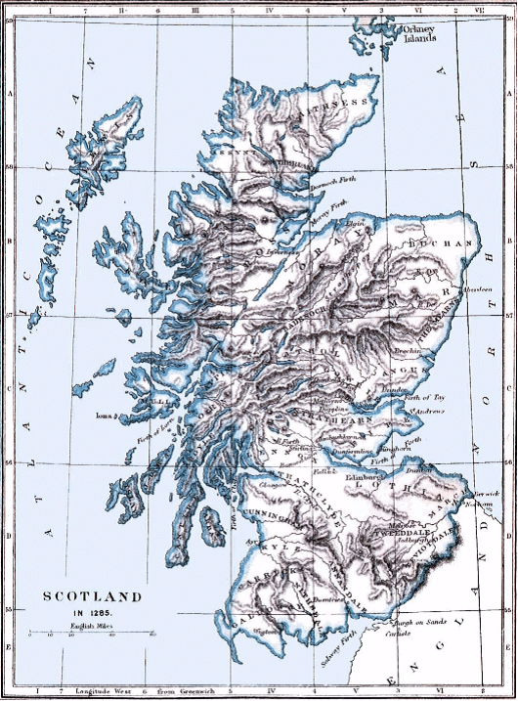
The ledgend is that the line of the Macnab chiefs is descended from a younger son of Kenneth MacAlpine who united the DalRitan kingdom, with that of the Picts in the 9th century, in what eventually became the Kingdom of Scotland. Lorn, Kintyre and Argyle, where the Irish DalRiata first settled, are on the long peninsula of Kintyre hanging down from the western coast in the area D-III on the map. Loch Tay, the traditional territory of the Clan MacNab is not marked, but is on the south side of the long blue lake just to the west of Dunkled, between Athol and Strathern at C-IV.
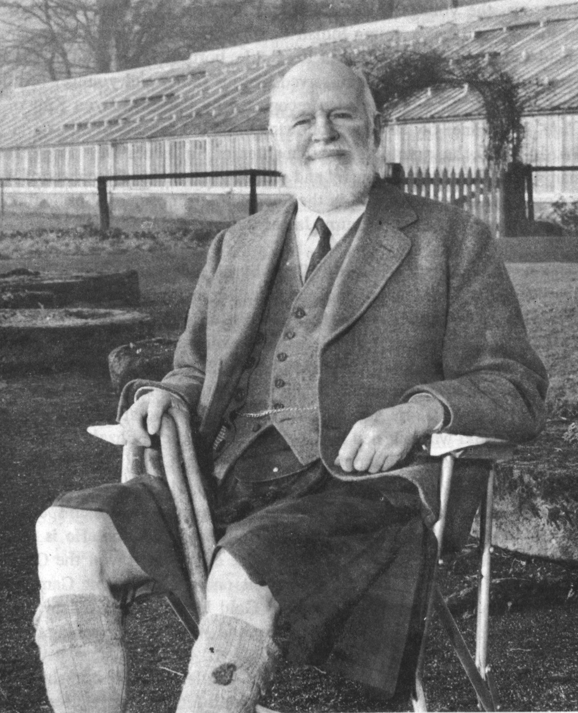Archibald Corrie MacNab of MacNab (1886-1971)
22nd Chief of Clan MacNab
Scanned from the Green Book
In 1949, Archibald Corrie Macnab bought back Kinnell House and 7,000 acres of land from the Bredalbane Trustees. In 1954, James Alexander Macnab, 21st chief de jure, relinquished his claim as chief to his uncle Archibald Corrie Macnab. Subsequently, on the evidence of a letter from Archibald Macnab (17th Chief) to Sir Allan Napier Macnab of Dundurn, information detailed in said letter and derived from the records of Sasines etc. in Register House, Edinburgh, he was recognized by the Lord Lyon the “de facto” 22nd chief.

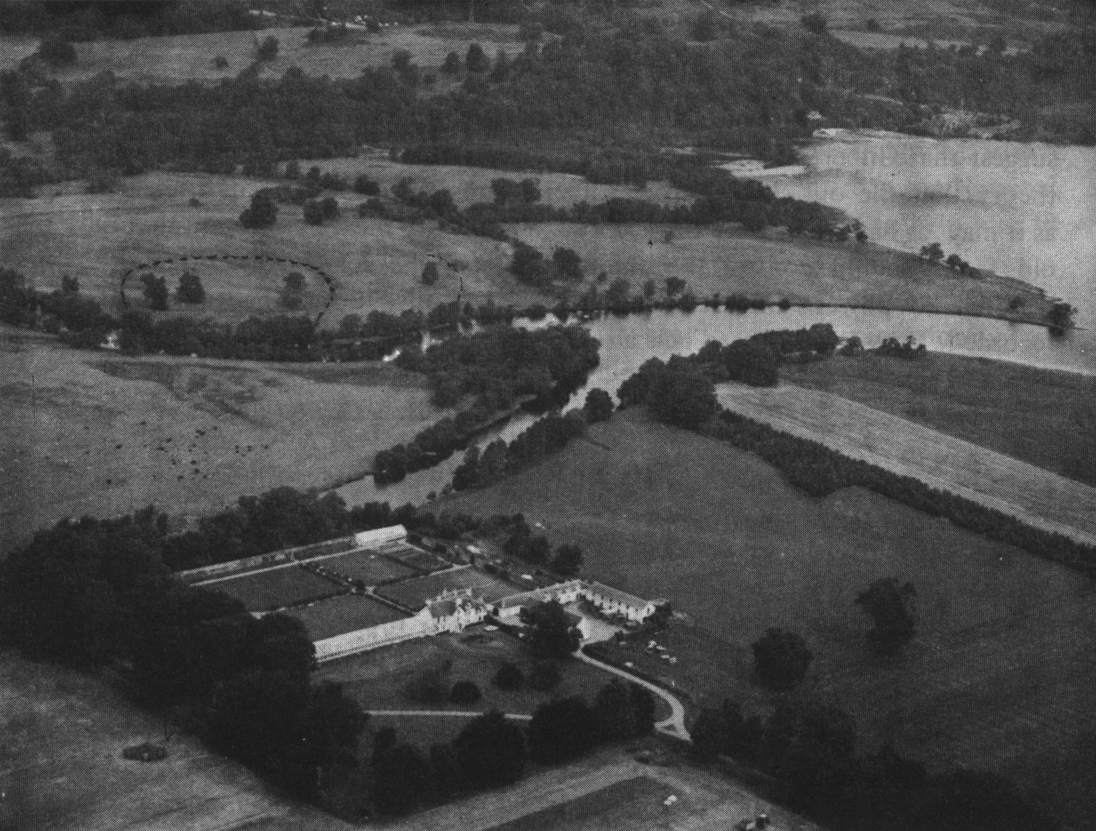This aerial view of Kinnell House, the historical seat of the clan chiefs was scanned from the Green Book.

The dotted circle on the far bank of the river Lochart denotes the site of Eilean Ran one time stronghold of the Macnabs. There are no longer any remains at the site, the stones having been removed and reused for other buildings. All that remains is the ditch that surrounded it.
Usually referred to as a “castle” it is more likely that it was a large “black house,” part dwelling, part barn, with dry stone walls and a thatched roof over cabers (timber beams). “Eilean” is Gaelic for “island” and the site, in the silted up mouths of the Dochart and Lochay rivers, was likely once an actual island surrounded by marsh and bog. The ditch, along with the marsh that surrounded it, served as the main defense of the inhabitants. The ground would not have supported anything like a stone castle or fortifiication. The surrounding area has long since been drained and turned into meadow.
Finlarig Castle, the stronghold of the Breadalbane Campbells, built by Grey John (Ian Glas) Campbell, lies just a quarter of a mile beyond Eilean Ran. At their instigation Eilean Ran was burnt by the English in 1654 though one suspects that the Macnab’s had already moved to Kinnell House across the river.

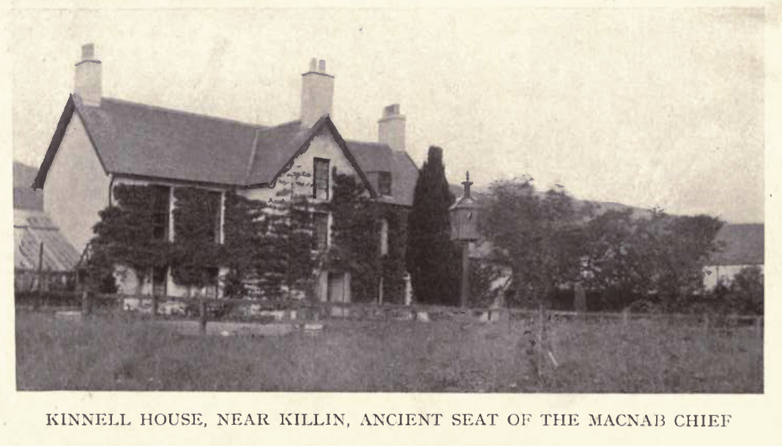
The following was adapted from an article written by Edward H. Nabb and published in the Dread Nought with additional information from “Old Killin, Kenmore and Loch Tay” by Bernard Byrom, published by Stenlake Publishing www.stenlake.co.uk No one knows when Kinnell House was built. It was standing in 1633 when Finley, the twelfth MacNab chief, gave it to his daughter-in--law, Mary, the daughter of Duncan Campbell fourth laird of Glenlyon, and is typical of country houses built at that time. Finley had married Katherine Campbell, a natural daughter of Sir Duncan and the house was probably standing largely in its present form in 1654 when his widow moved there, after Eilean Ran was burned by the English, along with all of the MacNab papers, records and documents, at the instigation of the infamous “Black Duncan of the Cowl” who lived at Finlarig.
In 1662 Alexander, the thirteenth chief, obtained a charter from John Campbell, the First Earl of Breadalbane, covering all of the MacNab lands except Eilean Ran which was never afterwards recovered. But the title to Kinnell House was somewhat confused. Smooth John’s widow married Malcolm MacGregor who exchanged certain rights in lands known as Ewer in return for any claim to Kinnell House. From that time onward it was the seat of the MacNabs until Francis, the sixteenth chief, took over at the death of his father, John, on February 19, 1778.
Francis inherited substantial debts, added to them greatly and at his death was thoroughly bankrupt. His nephew Archibald, the seventeenth chief, had a disposition of the MacNab lands in his favor in 1812 and by 1823 a writ of foreclosure was issued and part of the property was sold. An effort was made to sell the remainder but no purchaser could be found. Shortly thereafter Archibald went for a walk one morning with his gun and two dogs as if all was quite usual and he simply disappeared finally ending up in Canada.
Kinnell House passed to the Campbells of Breadalbane by way of a mortgage foreclosure and was in their possession in 1940, when the ninth earl moved there after his home at Taymouth Castle was requisitioned by the government for a hospital.
The Campbells fell on hard times and by 1946 all that was left of the Bredalbane estates were Kinnell House and a farm at Killin. In 1948 the house and some seven thousand acres of land were bought back by Archibald Corrie MacNabb.
In 1954 Archibald Corrie was recognized as twenty-second chief, when James Alexander MacNabb, twenty-first chief du jure surrendered his claim to the succession in his favor, with the understanding that James’s son, James Charles, would succeed Archibald.
Archibald Corrie MacNabb and his wife, Alice Macleod MacNab – daughter of the Chief of the MacLeod’s - greatly improved the property, both were oriented toward public relations and MacNabs from all over the world were welcomed into Kinnell House, until his death in 1970.
JAMES Charles Macnab of Macnab
Born: 14 April, 1926, in Killin. Died: 11 January, 2013, in Leuchars, aged 86 was the 23rd Chief of the Clan and known widely as The Macnab. He was a resolute and enthusiastic supporter of the clan’s traditions throughout his life and travelled widely to meet clan members – especially in Canada and the Far East. Although a small clan, Macnab did much to revive its membership at home and abroad.
He saw service in the late Forties, first with the Seaforth Higlanders and then with the Federation of Malaya Police, where he rose to acting Deputy Superintendent.
Macnab showed a fine understanding of the clan’s history when he was interviewed by STV at The Gathering in Holyrood Park in 2009. With a remarkable fluency for dates and the clan’s, at times, complex history,
Macnab told the interviewer with a delightful twinkle in his eye: “We’re not a big clan and throughout Scottish history we have a bit of a problem – usually fighting on the losing side of any major battle. We didn’t have much time for Robert the Bruce. Not on the right side at Bannockburn either, or Culloden.”
James Charles Macnab of Macnab was the elder son of Colonel James Alexander Macnab and succeeded his great-uncle as clan chief in 1970. The family home was Kinnell House, Killin, Perthshire, but due to death duties, much of the estate had to be sold.
Macnab was educated at Radley College in Berkshire and then, from 1940, attended Ashbury College, Ottawa. Aged 17, Macnab joined the Royal Air Force at Monkton, New Brunswick, but returned to Scotland in 1944 to train with the Scots Guards at Caterham. In 1945, Macnab was commissioned as a 2nd Lieutenant with the Seaforth Highlanders in Elgin. Later that year, he embarked for the Far East, serving initially in Bombay. Later, he was stationed at Bangalore and Madras and latterly experiencing active service during local unrest in Java.
After a spell in hospital for a severe illness, he returned to the UK and in 1948 was demobbed.
During his years with the Malayan police, Macnab demonstrated a sure grasp of both domestic and national affairs throughout the federation. After retirement in 1957, he returned to Scotland and managed the estate for his great-uncle. He was (1960-64) a Captain in the Seaforth Highlanders (Territorial Army) and a justice of the peace for Perthshire (1968-1975) and then for Stirling (1975-1986).
Macnab played a prominent part in all aspects of life throughout Perthshire – a county to which he was devoted. In 1961, he was elected to the Western Perthshire District Council, and from 1964 to 1975 was a county councilor for Perth and Kinross. He became a member of the Central Regional Council in 1978, serving with much distinction until 1982. His knowledge of Far East financial matters led to his appointment as an executive consultant with Hill Samuel Investment Services from 1982 to 1992.
His uncle had bought Kinnell House in 1949 and a large part of the former Macnab estate. When Macnab succeeded his great-uncle in 1970 as chief, he had to make major decisions how best to reorganize the family’s financial affairs. To cover the death duties, Macnab was forced to sell Kinnell House in 1978 and a large section of the estate. He lived at Finlarig and farmed at Tirarthur in Killin, until 1985, when he moved to Leuchars.
Macnab had married the Hon Diana Mary Anstruther-Gray, daughter of Lord Kilmany in St Andrews Episcopal Church, St Andrews, in 1959. The couple was devoted to furthering the fortunes of the Clan Macnab and took pride in wearing the tartan at all gatherings and ceilidhs. Their trips to the Far East were, for the couple, particularly memorable as it gave them the opportunity to revisit old friends, clan members and former colleagues with the police force. The visits to Canada also had a special significance for Macnab – not only had he been partly educated there, but also a former chief had lived there: so clan connections went back many years. Macnab was keen to resuscitate the Macnab Clan Society and, along with his son, announced at the 2009 Gathering that clan members could now join on the clan’s website. Macnab said with obvious enthusiasm: “We’ve got a hell of a lot of names in our books today.
”The Macnab was a keen shot, hill walker and enjoyed country pursuits. He was a member of the Royal Company of Archers.
His wife predeceased him and he is survived by their two sons and two daughters. Their elder son, James William Archibald Macnab, is the 24th Chief of Clan MacNab.ALASDAIR STEVEN
Read more at: http://www.scotsman.com/news/obituaries/obituary-james-macnab-of-macnab-chief-who-did-much-to-revive-clan-macnab-s-fortunes-worldwide-1-2774121

James Charles MacNab became the twenty-third chief and his wife, Diana, the daughter of Lord Kilmany, was responsible for the very tasteful redecoration of Kinnell House and the restoration of its gardens. Unfortunately, at the death of Diana’s father in 1985 they were forced to sell the estates for taxes and Kinnell House again passed out of MacNab ownership, while James and Diana moved to Kilmay, in Fife.
The following years brought about a great deal of confusion in the ownership and the title. A family named Morris bought the property, attempted to farm it and eventually failed. Several politically well connected joint owners followed in quick succession and at one time the makers of Dewar malt whisky considered buying the property but decided that they could not make justifiable use of it. In 1998 Bacardi Limited acquired John Dewar & Sons and the Dewar's brand and since it has been sold outside of the family that purchase is extremely unlikely.
It seems unlikely that Kinnell House will return to MacNab ownership in the foreseeable future. Only history can determine whether or not they will again inhabit this famous building which is home to every MacNab throughout the world.
It is generally considered that the Dormer in the upper floor of Kinnell was added by Francis in order to provide a large and spacious bedroom. During Francis’s lifetime a porridge cart used to set out every morning from Kinnell House and call at several houses in the village, dispensing breakfast for his bairns!
The entrance to Kinnell is a long, tree shaded drive with huge entrance columns made of fieldstone with a lion at the top of each. Off to the right is a pre-historic stone circle an outrider of which, is built into the walls of an old chapel which now serves as the estate office. A front entrance -- directly off the front of Kinnell House serves the cottage built by Alice Macleod MacNab when she moved out of Kinnell in 1970. It is also the site of the Queen Victoria fir tree planted by that Monarch during her visit. At one time there were 19 small cannons arranged around the semi circular drive in front of Kinnell House. These had been delivered and used to fire salutes for Queen Victoria during her visit and remained there for many years.
The contents of Kinnell House were included when the property was acquired by the Earl of Bredalbane and were an object of great interest to visitors to Kinnell until most were auctioned in 1935. Some of these possessions went to the Dewar whiskey family but some remained in Kinnell House and were turned over to the Macnab’s when the lands were repurchased and some of the items have found their way into the ownership of the present chief.
There is an interesting prophecy having to do with the MacNab lands. The Lady of Lawers, also known as the witch of Lawers, was famous for her prophecies and in about 1680 she announced that when a branch of a pine tree grafted to another the Macnabs would lose their lands. Of course this was highly unlikely as pine trees do not graft; however, in 1828 there was a great storm and a branch from one pine blew into the crotch of another pine, located on the MacNab burial grounds, and it indeed it did graft itself. It flourished and of course the Macnab’s lost their lands, then in 1949 the branch was still alive and the MacNab s had bought back their lands. It has since died and still hangs in its original position for all to see.
Below: an aerial view of Loch Tay and Killin Village. Kinnel House is clearly visible to the left of the Dochart, just beyond the village.

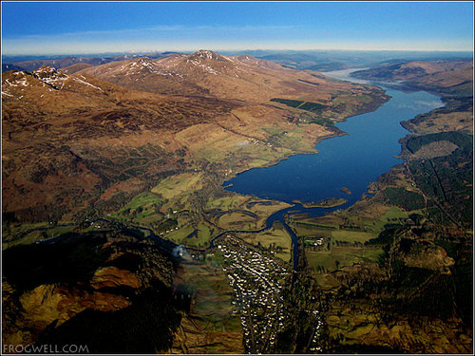
Our Chief, Jamie Macnab of Macnab...2014
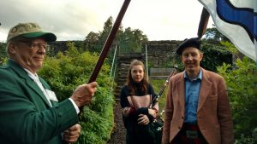
I was born on 22nd March 1963. My father was “Younger of Macnab" at that time. I can remember seeing a cutting from a newspaper saying that I was the "younger, younger of Macnab". Apparently a pipe band greeted my return to Killin from the maternity hospital in Edinburgh.
I had a very happy upbringing in Killin with my sisters Virginia and Katie and my brother Geoffrey. We lived first at Finlarig and then at Kinnell. I started at the local primary school but we were sent away to boarding school - I went first to Belhaven prep school and then onto Glenalmond college. My father had to sell Kinnell Estate due to the debts left by death duties while I was at school.
After school I spent 15 months in Australia working on sheep stations which belonged to my mother’s Australian cousins. The idea was for me to be toughened up by the experience but I think I came back pretty much the same person as I was before. On my return to the UK I worked as a land agent in Dorset for a year and then went to the Royal Agricultural College in Cirencester to do a diploma in Land Management. I joined Savills immediately after leaving college in 1987 in the land management department in Brechin in Angus.
After qualifying as a chartered surveyor I moved to Edinburgh as an assistant in the farm and estates sales department. I soon moved into country house sales - a job I have continued to this day. I specialize in properties at the top end of the market and have been fortunate to sell some of Scotland's best castles and country houses. I have met and acted for a wonderful range of people during my career.
I met and married Dr Jane Macintosh, a gynecologist, in 1994. We bought a large apartment in Edinburgh's Georgian New Town shortly after we married and have lived here ever since. We have been blessed with two fantastic children - Daisy born in 1999 and James born in 2000. James is the 9th first born son christened James in a row.
I was brought up into a rural way of life and did a lot of shooting when I was young. In my teens and twenties I played rugby - for my college and club rugby in Scotland. I had some speed so played on the wing. I also used to make some beer money running in the Lochearnhead Highland Games each year. As I slowed down my attention turned to golf. My mother's family (Anstruther) were original members of the R&A and I was very proud to become a member in 2011. I still cannot believe how lucky I am every time I tee up on the first on The Old Course.
I have followed my father becoming a Member of the Royal Company of Archers, The Queens Body Guard in Scotland. We parade at Holyrood Palace for the Royal Garden Party each year and I have also been on a parade at Buckingham Palace.
My father was keen to re-establish a Clan Macnab society in Scotland. Following the success of the Year of Homecoming in 2009 I have met with Alistair, Ken and Duncan Mcnab and we are moving slowly towards that objective. Our biggest challenge is finding a secretary who has time to get this up and going because we all struggle with the pressures of work, family and sporting lives.
I have been on the Executive of the Standing Council of Clan Chiefs as a representative of the heirs. This has given me a great insight into how the organisation and other clans operate.
I am mourning the recent death of my father James Charles Macnab of Macnab. His ashes and those of my mother will be interred side by side on Innis Bhuidhe (the clan the Burial Island) in Killin on 15th March, after a Memorial Service in The Killin Parish Church of Scotland.
I feel both proud and humble to now be Chief of the Clan. I hope that I can be a point of focus for Clansmen and women from throughout the world.
Gun Eagal
Jamie Macnab of Macnab

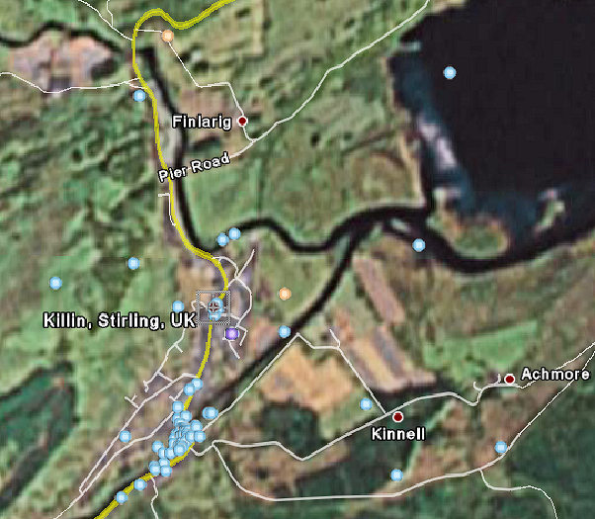
Satellite photo of Killin and the western end of Loch Tay.
Note the shallowness of the water as evident by the blue shadows off the shore of the loch, where the loch has been silted up over the centuries. The land at this end of the loch once must have consisted of marsh and bogs, now drained and converted into medow. Eilean Ran was in the bend on the north shore of the Lochay (coming from the north) just before it joins the Dochart (coming from the southwest) to flow into Loch Tay This photo (taken from Google Earth), fuzzy as it is, shows the relative locations of Finlarig, Killin, Kinnell House at the western end of Loch Tay.. The red dot labeled Kinnell is actually out of place. Kinnell House is at the end of the road going north from that intersection
The ruins of Finlarig Castle still stand, though they are unsafe. The blue dots on the satellite image are links to photos uploaded to Google Earth.
Map of Glen Dochart and Surroundings
Scanned from the Green Book
Barravorich (at top of map), Barr a Chaistealain (to the west by Dalmally), Auchesson, Inneshewan and Archlynle (along the north bank of the river Dochart) were seats of cadet branches of the chiefly family. Bovain, traditional estate of Macnab of Macnab also lies on the Dochart, across from Lix Toll.
The sites of the Breadalbane Campbells castle of Finlarig, the Macnab seat at Eilean Ran and Kinnell House, traditional residence of the Chief, lie by the village of Killen at the mouth of the River Dochart, where it runs into the western end of Loch Tay. Acharn, just to the south of Kinnell House, and once part of the Bovain Estaes, was home to the Archan branch of the Macnab’s from at least 1553. It is now operated as a bed and breakfast.
South of Killin is Glen Ogle which leads to Loch Earn and the traditional territory of the Macnish’s of Perthshire, the great enemy of the Macnab’s.
Glen Orchy to the west and Glen Lyon to the north were home to the Clan MacGregor until their lands were lost to the Breadalbane Campbell’s.
Dal Righ, between Tyndrum and Crianlarich is the traditional site of the ambush where MacDougal of Lorn nearly captured Robert the Bruce in 1306, reportedly with help from the Lord of Glendochart. Across the river Lorchy is St. Fillan’s Priory where a fugitive Robert the Bruce had rested the night before and received the blessing of the prior.
The Dewar’s were the hereditary guardians of the relics of St Fillan, each being given a croft, or small farm, to hold in return for this service. The locations of the various crofts are marked on the map (the Dewar Quigrich, Dewar Bernane, Dewar Fergy, and the Dewar Mesar).
The triangles labeled Ben Douran, Ben Lui, Ben More, Stob Binnein and Ben Lawers mark the peaks of the mountains that dominate the valley of the Dochart.
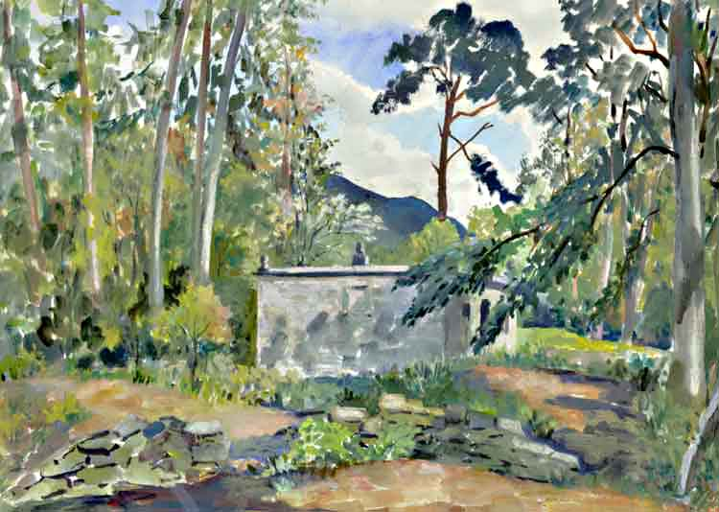The square stone enclosure within which lie the graves of the Chiefs on the island, known as Inch Buie, which lies in the middle of the Dochart at Killin and has been the clan Macnab burial ground from time immemorial. This watercolor was downloaded from the website of the Clan MacNab Memorial Trust. http://macnabclanuk.org/history1.html
The name Inch Buie is derived from the Gaelic “Inch Buidh” which means “Yellow Island” because of its golden colored turf. At the eastern end of the isle is a stone enclosure in which are buried fifteen high-ranking members of the clan including nine chiefs, other members are buried outside its walls. The round stone ornaments have disappeared from the corners but the carved heads in the middle of the walls still look down benignly on the sleeping residents and visitors.
Outside the enclosure, to the east are many stone slabs and mounds and two erect head stones.
In the early summer, when the young green of the larches and beeches is first showing itself and again in the autumn, when the flaming splendor of the beech leaves contrasts most effectively with the pale yellow of the larches and the greenish black of the pines, it is easy to understand how Francis (16th Chief) in his one known attempt to enter the hallowed bonds of matrimony, pleaded in vain with the object of his attentions that he owned the most beautiful burial ground in Scotland.
The island is now held by the Clan MacNab Memorial Trust for the benefit of the clan.
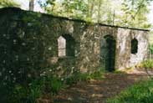
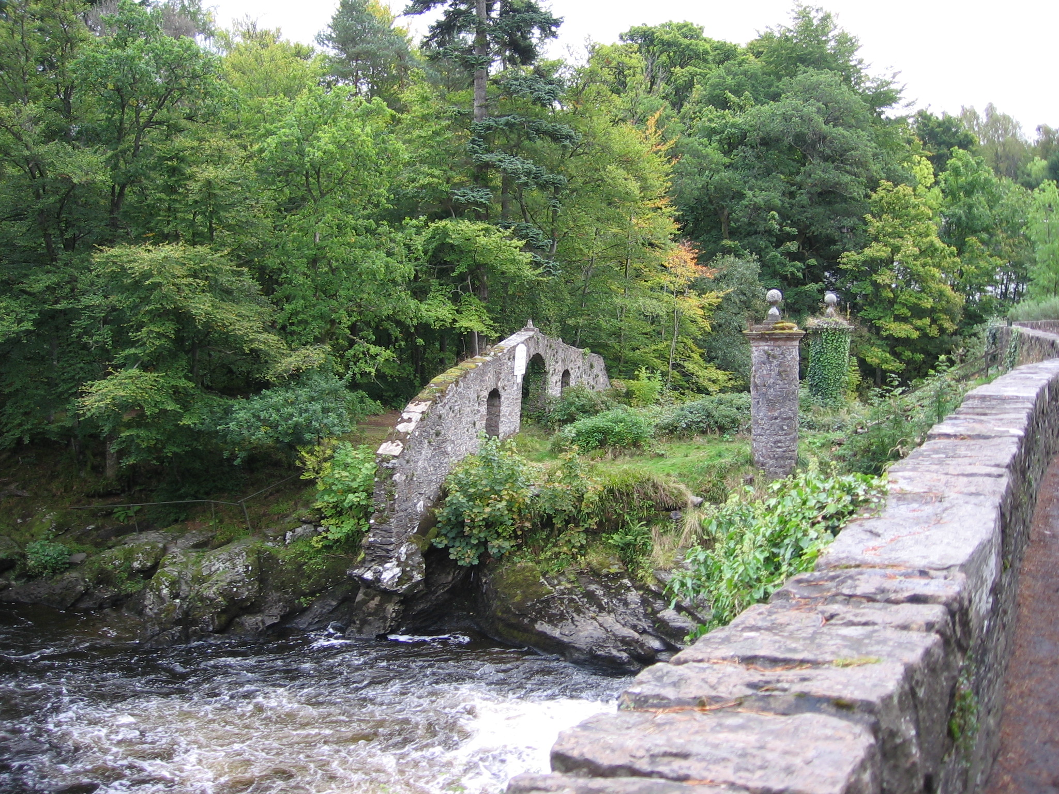This photo was taken from the bridge that spans the Dochart and depicts the columns and the wall with the Iron Gate that guard the entrance to the burial ground. Keys to the gate leading on to the island can be obtained from the Tourist Office in "the Breadalbane Folklore Centre," at the north end of the Dochart Bridge, where St. Fillans Stones are on display.
The photo was downloaded from Google Earth where other views of the island may also be accessed.
The small map of Killin shows the island in the middle of the Dochart and the location of the burial ground. The centre of the island is the site of two substantial forts of late prehistoric (Iron Age) date. It is still possible to discern their foundations beneath the ground. They are scheduled as ancient monuments.
In pre-history the island would have been an ideal site for a settlement – protected by a natural moat which would have provided both protection and a ready source of food

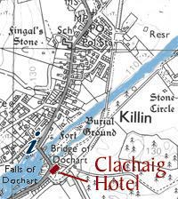

.

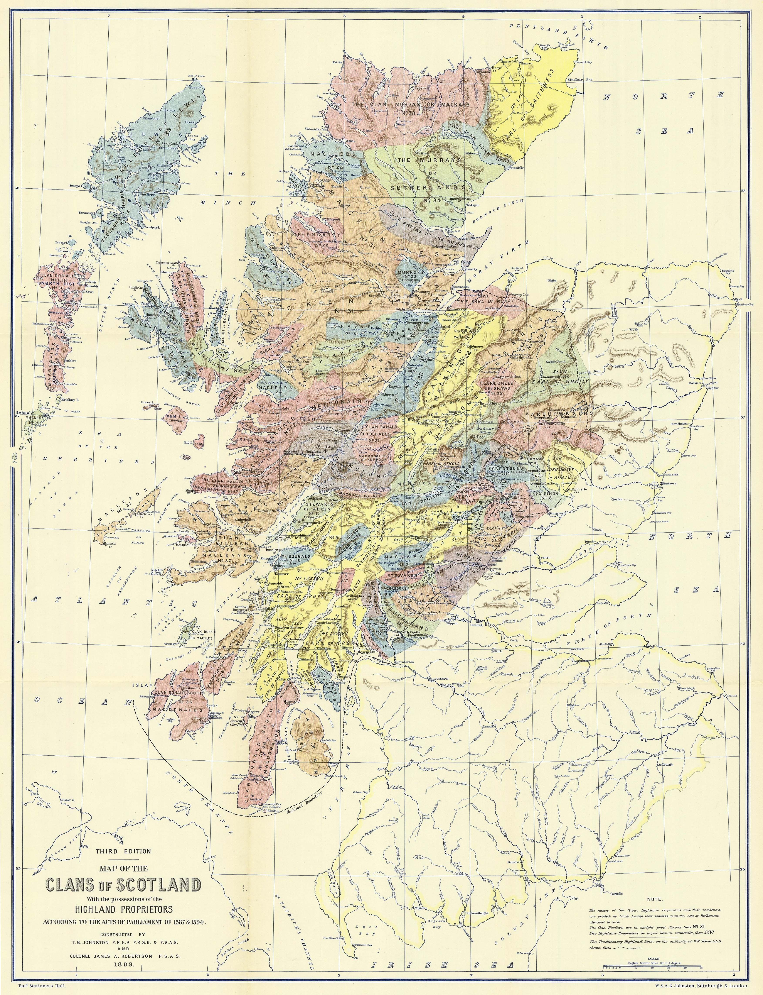Traditional Clan Territories at the end of the Sixteenth Century
The original of these maps came from the Electric Scotland Website at www.electricscotland.com/webclans/geog/index.htm. Though the map is dated 1899 it is colored to show the Historical Geography of the Clans of Scotland as enumerated in two Acts of the Scots Parliament, passed in 1587 and 1594 respectively. At this early date most of the Highland tribes were still in occupation of the lands they had inherited from their forefathers although in most cases the clan territories can be only approximately indicated.
The numbering of the Clans and Landlords has been made as they occur in the Acts of Parliament, the Macnabs being number 3 on that list.
The residences of the chiefs and heads of families are marked in black, having the number of the clan below in upright print,
01 Buchanans
02 MacFarlanes
03 MacNabs
04 Grahams of Menteith
05 Stewarts of Balquhidder
06 Clan Gregor, the MacGregors
07 Clan Lauren, the M’Larens
08 Campbells of Lochnell
09 Campbells of Inverawe
10 Clan Dougal, M‘Dougals
11 Stewarts of Appin
12 Clan Ian Abrach, or Macdonalds of Glencoe
13 Stewarts in Atholl, and parts adjacent
14 Clan Donachy, or Robertsons of Atholl, and parts adjacent
15 Menzies
16 Clan M’Thomas, in Glenshee
17 Fergusons, in Glenshee
18 Spaldings, in Glenshee
19 M’lntoshes of Glentilt
20 Clan Cameron
21 Clan Ranald of Lochaber, or Macdonalds of Keppoch
22 Clan Ranald of Moydart, Knoydart, Arasaig, Morar, and Glengarry
23 all Macdonalds
24 MacLeods of Lewis
25 MacLeods of Harris
26 Clan Neil, or MacNeils
27 Clan Kinnon, or MacKinnons
28 Clan Macian, or Macdonalds of Ardnamurchan and Sunart
29 Clan Chattan, Macphersons and Mackintoshes
30 Grants
31 Frasers
32 Clan Kenzie, or Mackenzies
33 Clan Anrias, or Ross’s
34 Munroes
35 Murrays, or Sutherlands
36 Clanquhele, or Shaws of Rothiemurchus
37 Clan Donald, north and south, Macdonalds
38 Clan Gillean, or MacLeans
39 Clan Morgan, or Mackays
40 Clan Gunn
41 Macaulays
42 Galbraiths
43 Farquharsons

List of Chiefs and Landlords as given in the Act of 1587
The possessions of the landlords are named in italics with Roman numerals.

IV. Humphrey Colquhoun of Luss
XVII. James, Earl of Moray
XVIII. Patrick, third Lord Drummond
XX. Sir Duncan Campbell of Glenorchy
XXI. Sir John Campbell of Lawers
XXIV. Colin Campbell of Ardveck, brother of Sir Duncan Campbell of Glenorchy
XXV. Colin Campbell of Glenlyon
XXVI. John, fifth Earl of Atholl of the Innermeath line
XXIX. John Murray of Strowan, in Strathern
XXXIX. James, second Earl of Gowrie, and fifth Lord Ruthven
XLI. James, sixth Lord Ogilvie of Airlie
XLVII. George, sixth Earl, and first Marquis of Huntly
LII. Alexander Chisholm of that ilk, and Strathglass
LXI. George, fifth Earl of Caithness
LXXXV. John Stewart, Sheriff of Bute
LXXXVII. Archibald, seventh Earl of Argyll
LXXXVIII. Duncan Campbell of Auchinbreck
LXXXIX. Sir James Campbell of Ardkinglas
XC. Malcolm Macnaughtan of Dundaraw
XCI. Archibald Maclachlan of Strathlachlan
XCII. James Lamont of that ilk, Inveryne
XCIII. Colin Campbell of Barbreck
XCIV. John Campbell of Duntrune
XCV. Sir James Scrymgeour of Dudhope and Glassary
XCVII. Archibald Campbell of Otter
C. Murdoch Macfie of Colonsay
CI. John, first Marquis of Hamilton

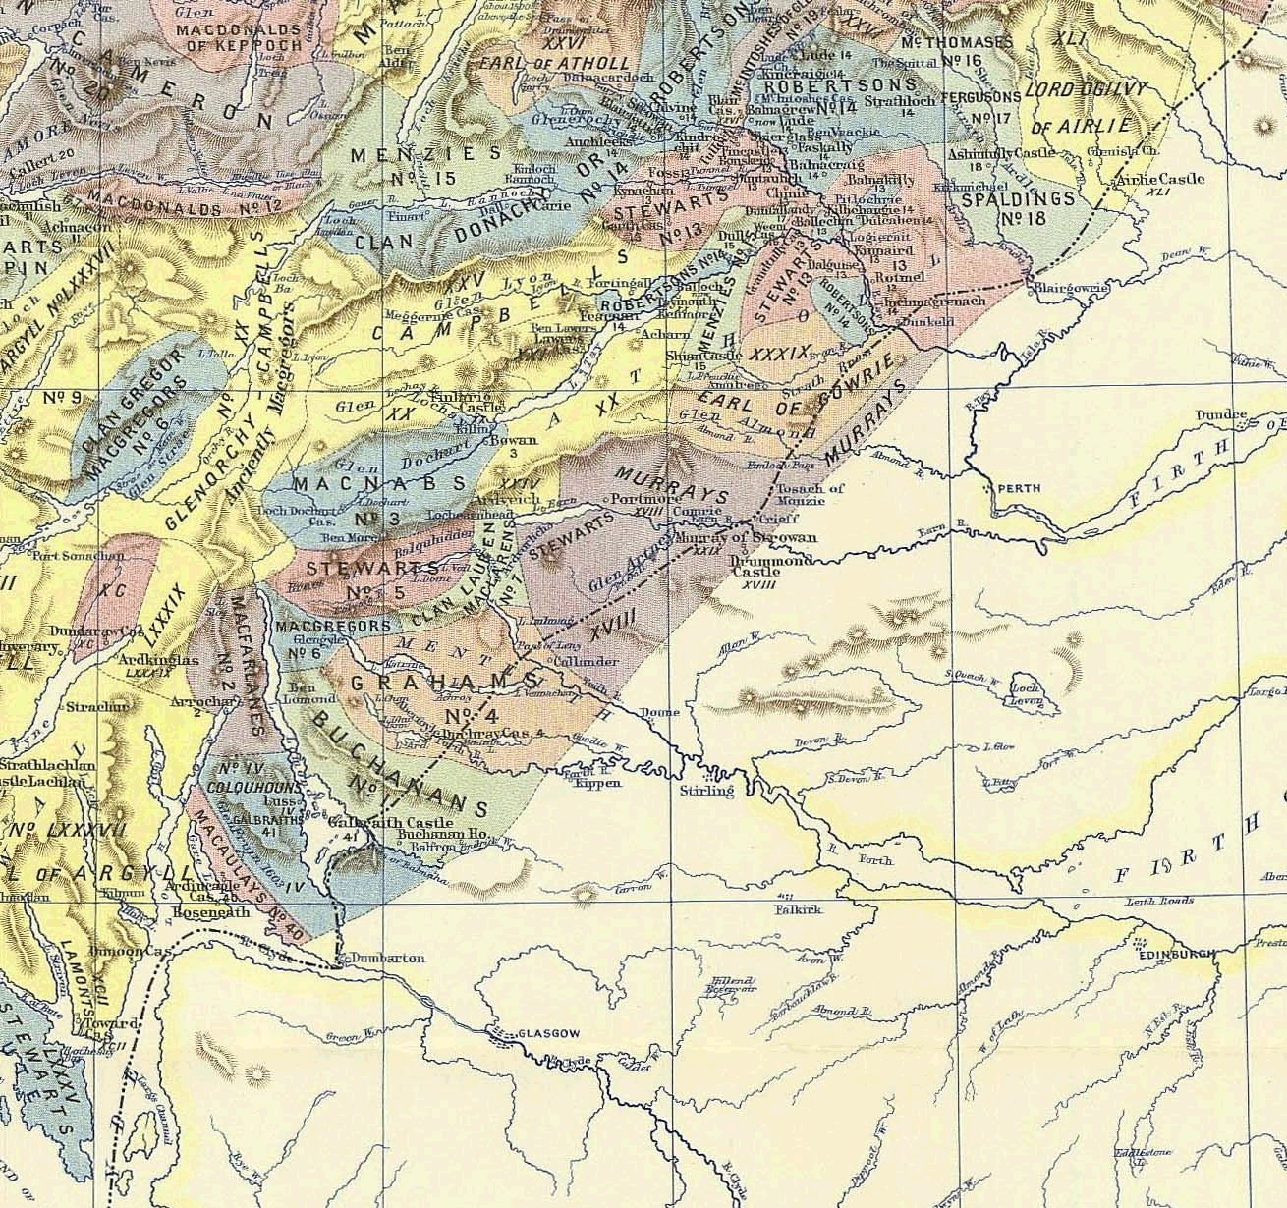
Detail from the large map, showing the territory of the Clan Macnab and their neighbors the Campbells and MacGregors with some Stewarts and other small clan territories

The Macnab’s occupied the glen of the river Dochart, which runs from west to east to empty into Loch Tay. Near the mouth of the Dochart, where it empties into Loch Tay, is the MacNab estate of “Bowan” (Bovain in its modern spelling) and the village of Killen. The Macnab burial ground of Inch Buie is there, on an island in the middle of the river and just above Killen is the Campbell stronghold of Finlarig Castle, only a quarter mile from the site of the MacNab’s seat of Elian Ran, which was destroyed by the government at the instigation of the Campbell’s in 1654
In 1828, the Marquis of Breadalbane, principal creditor of the MacNab estates, exercised his right of purchase, after Archibald Macnab, 17th chief of Clan MacNab had fled to Canada to escape his debts.
Subsequent to the Marquis of Bredalbane’s purchase of the MacNab estates he followed up on a suggestion that he introduce the capercailzie (a large black Old World grouse) to his estates for sport.
This effort did not initially meet with success as the following article from the "Inverness Courier of 1840 suggests:
May 6.—an account is given of an effort to introduce the capercailzie on the Breadalbane estates. Mr Fowell Buxton had received a pair from a friend in Sweden, which he kept in Norfolk. They bred, but in the hot weather all died except the cock, which was afterwards accidentally shot. In 1837 Mr Fowell Buxton was shooting on the Marquis of Breadalbane’s moors, and proposed to him to make another trial with the capercailzie. "Mr. Buxton sent his gamekeeper all the way to Sweden on purpose to bring the birds to Scotland; and the same friend who had formerly assisted succeeded in procuring sixteen hens and thirteen cocks. Part of them died by the way, but the greater number arrived safe, and were conveyed to Taymouth Castle. Some of the birds were turned out in the autumn of 1837, and part were kept in a house. In the year 1838 a brace only were reared by the keeper, but two fine broods were seen in the woods. In the summer of 1838 sixteen hens were forwarded to Taymouth. In the spring of 1839, instead of attempting to rear any capercailzie, the Marquis’s game-keeper placed the eggs laid by the birds in confinement, in the nests of grey hens, which brought them up in a wild state." The experiment had so far answered fairly well, but the head-keeper did not feel assured of the final result. He says that the Marquis of Breadalbane had abstained from shooting a single capercailzie, and had even forbidden the shooting of any black-game in the neighborhood of Taymouth, lest a young capercailzie might be killed by mistake; but others had not been so scrupulous. "I mention this," says the keeper, "because I am convinced that these birds cannot generally be established in the North of Scotland unless sportsmen will unite to preserve them for some years to come, and until their numbers are very much increased."
In 1849, the remaining Macnabs were evicted to make room for the capercailzie. A century later in 1949 Archibald Corrie MacNab bought back Kinnell House and 7,000 acres from the Breadalbane Trustees. In 1954 James Alexander Macnab, 21st chief de jure relinquished his claim to the succession in favor of his uncle, Archibald Corrie, who was recognized by the Lord Lyon as the “de facto” 22nd chief of Clan Macnab. However, following Archibald’s death, his nephew James Charles Macnab, son of James Alexander 21st chief de jure became the 23rd chief. Faced with a large death duty liability on the estate he eventually had to dispose of all of it except for the island of Inch Buie which is now held in a perpetual trust.
The Clan Nish or Macnish, who were the great enemies of the Macnab’s lived south of Loch Tay in the area around Loch Earn, their last stronghold an island in that loch.
West and south of the Macnab lands are the remnants of the Macgregor territories separated by the Glenorchy Campbell’s, noted as “Anciently Macgregor’s.”
The Macgregor’s had held Glen Orchy and Glen Lyon by right of first occupation and had no written charters giving them title to the land. As the Campbell’s gained power at court they obtained charters for land they coveted and gradually reduced the Clan Gregor to tenants in their own country.
John Campbell yr of Glenorchy (1635-1717) the son and heir to Sir John Campbell Bt., who acquired the Macnab estates, turned land acquisition into an art form. He would buy up IOU’s of less provident landowners then foreclosed on the debts and took over the property at bargain prices. In 1672, as the principal creditor of George Sinclair, Earl of Caithness, he obtained a conveyance of all the Caithness lands and titles, of which he obtained a Crown Charter in the following year. Glenorchy did not insist on taking up his legal rights but lived with the former Earl and his wife, allowing him to keep outward show of his former status. Sinclair died in May 1676 and in June 1677 Glenorchy, who had in the meantime married the former Caithness’s Widow Mary Campbell, a daughter of the Marquess of Argyle, claimed and was granted the Earldom of Caithness together with the title of Viscount of Breadalbane. However, possession of the lands required an armed invasion in the face of determined opposition by George Sinclair of Keiss, the Caithness heir male.
Grey John sent round the fiery cross and raised seven hundred men between the Tay and Orchy. He gave command to Robert Campbell of Glenlyon who marched north and slaughtered the Sinclairs. But George escaped and took his just complaint to the king.
King Charles II, disliked subjects who awarded themselves titles and In 1681 cancelled his grant to Glenorchy and gave it to George Sinclair. On August 13, in its place he created Glenorchy the Earl of Brea d’Albane (Breadalbane) Viscount of Tay and Paintland, Lord Glenurchy, Benederaloch, Ormelie and Weick. In 1685, when Charles II died and James VII succeeded, Breadalbane had become the king’s most powerful Scottish subject.
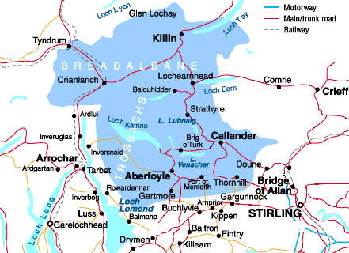The area of Breadalbane has never been defined although it is generally understood to cover an area stretching roughly from Tyndrum in the west to Aberfeldy in the east, Loch Earn in the south to Glen Lyon in the north.
Brea d’Albane comes from the words “Brea,” an unusual form of “Brae” meaning specifically the brow of a hill or more generally hills or high ground adjoining a river. Alba is the ancient name for the kingdom that became Scotland, hence, Brea d’Albane = The Heights of Scotland.
In common usage Brea d’Albane has become run together as one word as Breadalbane and the Earls are simply known as the Earls of Breadalbane.
A personal note:
My 2nd great grandfather, John McNabb, immigrated to Glasgow, sometime before 1800, and found employment in the cotton industry in the town of Pollokshaws, just southwest of Glasgow and within the county of Renfrewshire. We do not know where John McNabb or his wife, Ann Buchanan, was born. The first record we have of them is from the Parochial Register of the Parish of Eastwood, County of Renfrew, in 1800, when they were booked for 3 days proclamation on October 16th. Much later, in the 1841 Census, “562 Eastwood, County of Renfrew, at Thornliebank,” they are noted as having been “Not born in County.”
During the late 17th and early 18th centuries many highlanders migrated to the newly industrializing cities area of Glasgow, in search of work in the cotton industry. As the map indicates Glasgow is directly south of the traditional Macnab territories and the Buchanan lands lie directly in between. Assuming that John McNabb was a highlander, it seems reasonable that as he traveled south to Glasgow looking for a better opportunity he would have passed through the Buchanan lands. We would like to think that he may have met his future wife, Ann Buchanan on his way to Glasgow or traveled with her family. We will never know but it would make a good story should someone care to write it.
David Rorer

References:
CLANS, SEPTS, AND REGIMENTS OF THE SCOTTISH HIGHLANDS, by Frank Adam. Revised by Sir Thomas Innes of Learney, Lord Lyon King of Arms, seventh edition of 1965
www.electricscotland.com/webclans/geog/index.htm
The Great Feud, the Campbells & the Macdonalds by Oliver Thomson 2000. Sutton Publishing (www.suttonpublishing.co.uk)
“Rob Roy MacGregor, his life and times,” by WH Murry. Canongate Books, Edinburgh. www.canongate.net
A History of Clan Campbell, Volume 3, From the Restoration to the Present Day, by Alastair Campbell of Airds, Unicorn Pursuivant. Published by Edinburgh University Press 2004

A HISTORY OF THE HIGHLAND VILLAGE OF KILLIN, and the surrounding district of BREADALBANE
(The first part of this is taken from the Killin Village Website @ www.killin.co.uk )
The story of Killin and the surrounding area of Breadalbane, since recorded history, is as exciting, as villainous and as romantic as the history of any other part of the highlands of Scotland. The area of Breadalbane has never been properly defined although it is generally understood to cover an area stretching roughly from Tyndrum in the west to Aberfeldy in the east, Loch Earn in the south to Glen Lyon in the north. Until recently these were Campbell lands, although lived in by men of other clans as well whose loyalty was never given to a Campbell overlord. These Breadalbane Campbell’s owned extensive lands out with the Breadalbane area as well, at one time in the nineteenth century being the largest private landowners in Scotland. Their lands stretched from the Atlantic near Oban to nearly the North Sea near Dundee. The Breadalbane’s had started out Lords of Glen Orchy, kinsmen to the Dukes of Argyll, and as their lands spread east they moved from Argyll, first to Finlarig and latterly to Taymouth, called Balloch when they first moved to it.
Those with knowledge of the Gaels will know that they prided themselves on their oral knowledge of their history handed down father to son, family to family with the result that a lot of their history is anecdotal. It should be nonetheless accurate for that, as a lot of this folklore is actually recorded elsewhere although perhaps not with the gloss or bias it might receive when relating to a storytellers clan or district.
The Killin district is known to have been well populated in prehistoric times due to the number of ancient artifacts still to be found in the area. This ranges from a Stone Age axe factory on the side of Ben Lawers, Bronze Age “ring marked” stones at Dunchroisk, Crannogs in Loch Tay and Druid standing stone circles throughout the area. Crannogs are artificial islands built near the edges of a loch but out in the water. They were built for defense from other tribes and protection for themselves and their stock from predators. The Crannogs are still visible today although many look just like spits of land jutting out into the loch because the stretch of water between the bank and the Crannogs has progressively silted up.
Crannogs are now covered in vegetation and are unrecognizable from normal land at the surface. However surveys done of them underwater have revealed much of their structure. At Acharn near Kenmore, a replica of a Crannog dwelling place has been built and is well worth a visit.
As we move into recorded history, we know that the area was well populated with people. These people were constantly in flux as other tribes pressed into their territories and they pressed into others territories in common with populace movements at that time throughout Europe. There would be exterminations, assimilation and victorious defenses by these peoples over many centuries as they were welded into the Pictish tribe that they were to become. As the Pictish tribes emerged, we can start to actually begin tracing the known history of these people. They have left us no written word however; there is a lot of evidence both historic and oral that gives us clues to the lifestyle of these peoples. These people were in contact with the Romans on and off for more than three centuries. The Romans had camps all around the southern extremities of the Breadalbane area although these are temporary camps made during particular campaigns. The permanent camps were behind both Hadrian’s Wall and Antonine’s Wall at various times during the Roman occupation.
Even during the Roman occupation there were people moving into Scotland from various directions. After the Romans, came Angles, Saxons and Jutes from the east and south; Scots from the west and later still the Vikings from the north. The Picts however, for centuries were really only troubled round the margins of their territories. As the warlike tribe they were, they were unbeatable in their strongholds. Breadalbane must have been one such stronghold as it is about as far from the sea as you can get in central Scotland.
We know Viking incursions came as far west as Dunkeld and the Scots settled much of Argyll but could get no farther. However in the ninth century Kenneth McAlpine effectively united the Picts and Scots beginning Scotland as we know it today. The powerful leaders in the different districts at this time were the people who would later emerge as the clan chiefs during the heyday of the clan system. As Breadalbane was a Pictish stronghold it is no surprise to find that the oldest clan structure, the Siol Alpin, was very much of this area.
The legendary stories of Fionn (Fingal) are known throughout Scottish and Irish history. There is no real way to know if there was a Fingal or if they were a collection of heroic stories which through retelling came to be related to one hero. However, the fact is the stories are told all over, from the formation of the Giant's Causeway in Northern Ireland to Fingal's Cave in Staffa. The story as it is told in Scotland is that Taileachd lived on Eilean Lubhar an island in Loch Dochart and he had a fairy sweetheart. Fionn got to know this lady quite well and was seeing her.
Taileachd found out about the relationship and when he confronted Fionn they both became so jealous that the lady, frightened of their intentions to each other said that she would follow the winner of a competition that she would set. This competition was to find out who could leap the farthest, so Taileachd leapt from the island to the shore and Fionn leapt after him. Taileachd then challenged Fionn to leap backwards back across the channel, Taileachd leapt first and landed on dry ground; Fionn leapt next but landed closer to the shore and sank up to his neck in the soft silt. This gave Taileachd his chance and he cut off Fionn's head. However he knew Fionn's warriors, the Fiann, would be out to avenge him, so taking the head he set off to hide. The Fiann found Fionn's headless corpse heard the story of what had happened and set off in pursuit. When Taileachd had reached the head of Loch Laidon he had grown tired of carrying the head he put it on a pole on the top of a black knoll at a ford in the river. This ford has ever since been called Ath Chinn (the ford of the head). When the Fiann came upon the head they put their finger under Fionn's tooth of knowledge and this revealed to them that Taileachd was hiding out in a cave on the side of Ben Alder. They captured him there and when he refused to repent they slew him. Fionn (Fingal) was buried behind a knoll in a grave ever afterward-called Cill Fhinn (burial place of Fingal). This is said to be one of the meanings for the name Killin (in the Gaelic an "h" after a letter aspirates the preceding letter, making the "f" in this context silent).
Fingal's Grave
The other main contender for the root of the name Killin is Cill Linn, which means the church by the stream. Other oft-quoted contenders are The White Church or Holy Church although they do not make as much sense as the previous two. There are countless references to Fingal, Fionn and Fiann and the Fingalian legends in place names throughout Breadalbane, Finlarig, Finglen being but two. Fingal and the Fiann were also reputed to be the protectors of the district from invaders such as the Romans. The saying was "Forty castles has the Fiann in the long crooked glen of the stones" (Glen Lyon), remains of these can be seen to this day all the way up the glen.
Recorded history in our area only begins with the coming of Christianity in the seventh century and the two main missionaries to our area are St Fillan and St Adamnan. The tradition is that they traveled together to the headwaters of the Tay at Tyndrum, where they drew lots to decide in what area they would labor. Adamnan drew the northern and eastern area (Glen Lyon to Aberfeldy) and Fillan drew the western end (Loch Tay to Tyndrum). Adamnan's seat was at Dull and Fillan's seat was at Glendochart where they both labored long and hard to bring the people of the area into Christianity. Some of the relics of St Fillan, which were individually looked after by a Dewar (keeper) have been lost but his bell and crozier are now with the Museum of Antiquities in Edinburgh. These saints founded chapels in many of the main settlements in their districts. The people who lived in these settlements would be the Siol Alpin progenitors of the clans and when clans were formed, they associated themselves with their district or with a powerful lord. The clans of our area retained or expanded their lands by the power of the sword. This way of life lasted longer in this area than in other areas and caused problems for these clans when it became customary to hold lands by charter.
In Breadalbane the clan system flourished from the earliest days until well into the nineteenth century. It is not surprising therefore to find that the Macgregor’s and the MacNab’s, both part of Siol Alpin were here from earliest times. In fact, the Macgregor’s are the senior line of Siol Alpin and it is thought that these Macgregor’s originally peopled from Argyll right through to the eastern end of Breadalbane. The MacGregor’s trace their name from a junior line of Kenneth MacAlpine hence their motto "Royal is my race.” The Macnab’s it is thought came from a Macgregor abbot of Glen Dochart whose children were known as "son of the abbot.” Other clans of the district were the MacNaughtans, MacDiarmids and Menzies and latterly the Campbell’s, who were latecomers but ultimately became the major force in the area. The MacNaughtans name means son of Nechtan, (Nechtan was a Pictish king) proving that this name comes from antiquity, prior to the coming of the Scots. The MacDiarmids name means "son of Diarmid," the Campbell’s are known as clan Diarmid, so there must be a link somewhere although the MacDiarmids were long in the district before the coming of the first Campbell.
The Macnab's star started to wane in the 14th century because they were on the wrong side during the Scottish Wars of Independence. They were allied to the MacDougall’s of Lorn who in turn were allied to the Comyns rivals for the throne with Robert the Bruce. When Robert the Bruce slew the Red Comyn in Greyfriars Kirk in Dumfries and dashed to Scone to be crowned King of Scots these seeds were sown.
After the crowning Bruce met an English army at Methven in 1306, his army was all but destroyed and the remnants, Bruce included, made their way into the Highlands of Perthshire to evade any other English army detachments. It is not sure if they traveled up Earnside or Tayside but they certainly made their way up Glendochart. They would not have been able to travel in this area without being noticed by the Macnab’s the most powerful clan in the area, in those days far more powerful than they were latterly. The Macnab’s passed the word to the MacDougall’s who set a trap. Robert the Bruce’s party stopped and rested at the small church of Strath Fillan where the abbot blessed the Bruce who was very grateful for this act, as the Church of Rome had excommunicated him following the murder of the Red Comyn.
This was still a church of the Culdees, the original church of St Fillan and it had no allegiance to the Church of Rome. The Abbot is also supposed to have warned Bruce he was in dangerous territory and should get out as soon as possible. Not long after the party had left Strath Fillan they were ambushed by the MacDougall’s and supposedly the Macnab’s at Dal Righ (the Kings Field) near Tyndrum. Bruce only just managed to escape with his own life, a MacDougall clansman got close enough to grasp Bruce's cloak before Bruce had killed him. When the clansman was found later, he was still clasping the cloak and in his hand was a brooch that held the cloak. The MacDougall’s still have that brooch to this day and it is called the brooch of Lorn. Bruce and most of his party escaped and hid out all over the Highlands and Islands building up the army that was eventually to win the Wars of Independence for Scotland.
When Bruce had consolidated his Kingdom the time came to pay his friends and enemies. The Macnab’s had their lands ravaged and burned and their standing severely reduced, while the Abbot of Glendochart got a new church built and dedicated for his help and assistance. It is said that at the Battle of Bannockburn it was the relics of St Fillan that was paraded in front of the Scottish troops before the battle to remind them of their history and antiquity and to show them their destiny. Bruce also proclaimed the rights of the Church of Glendochart and to the Dewars (Keepers) of the relics of St Fillan. This law was to prove invaluable nearly two hundred years later when the Bishopric of Dunkeld tried to claim the relics for himself.
The MacNab’s ever afterward struggled to maintain their estates and their own lifestyle added to the difficulties. They long held the view that in their own backyard they were immune from the rest of the world and that the king's writ did not extend as far as Killin. For many years this seemed to be true, during the heyday of the clans the MacNab’s were a law unto themselves and ruled the area with an iron fist. However toward the late sixteenth century the House of Glenorchy, the Campbell’s were moving into the area and as they became bigger and bigger creditors to the Macnab gradually took over more and more of their traditional lands. Eventually the law arrived as well and the MacNab’s could then be forced to pay their debts. Archibald Macnab the 17th Clan Chief eventually fled to Canada in 1823 as the estates were in such a perilous financial condition. The Marquis of Breadalbane as one of the largest creditors got his pick of the rest of the estate, while others bought the rest as creditors or from creditors and so ended the Macnab clan association with Killin.
Today there is not one of the name of Macnab or Dewar living in the village of Killin. They are scattered to all of the ends of the earth with a fair proportion in Canada and some have become very famous.
Clan Campbell's Scotland
Finlarig near Killin was one of the main strongholds of Clan Campbell. The earliest traceable ancestor of the Breadalbane family, and first of the house of Glenorchy, was Sir Colin Campbell, the third son of Duncan, first Lord Campbell of Lochow. The Campbells were a powerful Clan with a burning desire to expand their lands, indeed the ambition of the 16 century Black Duncan Campbell of the
Cowl was to be able to travel on his own lands from the east to the west coast of Scotland, one that he achieved to the cost of many of his neighbors. The Campbells acquired their lands mainly through guile and legal process, largely with the support of some of Scotland’s kings. It was the Campbells who hounded the MacGregors, the MacEwans, MacNabs and many other unfortunate clans from their lands.
The Campbells were also great castle builders, owning at one stage castles spread over the full width of Scotland, including: Dunstafnage and Barcaldine near Oban, Kilchurn on Loch Awe, Lock Dochart Castle, Finlarig at Killin, Ardeonaig castle on Loch Tay and Balloch castle (later known as Taymouth) at Kenmore. Sir Colin Campbell, born about 1577 was probably the most notorious of the Campbells and it was he who hounded the unfortunate MacGregors of Glenstrae and their successors. The fortunes of the clan slowly changed and the last straw was the curse invoked by the 'Old Woman of Lawers' who predicted the extinction of the Campbells. The final problems for the Campbells started in the 1920s with taxation and the lack of direct descendants. They sold off their lands to meet debts until 1948 when the last land was sold.
Sir Colin Campbell the great expansionist had built Finlarig Castle at Killin and behind it the family mausoleum. The mausoleum was a ruin when the last of the Campbells of Glenorchy died early in the 20th century. Beyond the ruins of the mausoleum and facing the ruins and Finlarig castle are two graves with Celtic crosses inscribed for Sir Gavin Campbell, Marquis of Breadalbane, and his wife of 50 years, Lady Alma St. Fillan, the Last of the Breadalbanes!
Breadalbane
The name Breadalbane refers mainly to the lands owned by the Campbells from Oban to Aberfeldy. The Name Breadalbane derives from the old Celtic words signifying "high Albane" or "the high part of Scotland in the kingdom of Albany". The area is steeped in history, much of it recorded in ancient records, much recorded in ancient Pictish carvings and before that. Evidence of early occupation lies in 'cup and ring' markings which are found carved in the rocks all over Breadalbane. This is a beautiful part of Scotland, boasting some of the highest mountains and most beautiful and stunning scenery in Scotland. Along its length is loch Awe, Loch Dochart and Loch Tay as well many minor lochans. Mountains like Ben More, Stob Binnian, Ben Lawers and the Tarmachan range line both sides of the river valley. Sparkling little jewels of villages like, Killin, Kenmore and Fortingall are spread along the length of Breadalbane.
Castles of Breadalbane:
Barcaldine castle
Barcaldine, the "Black Castle" of Benderloch is one of the few mediaeval castles in Scotland which is still habitable and which appears practically unchanged. Throughout its 400 year existence, Barcaldine has been a military outpost, a dwelling house, a ruin and now, in the 21st century, a place of interest for visitors to the area to enjoy.
Barcaldine Castle is built on the "L" plan with the smaller wing on the south side projecting to the west beyond the end part of the main wall of the castle. This projection enabled the main wall to be protected and covered with small arms. The walls are approximately 9 feet thick, thus allowing the stair passage inside them, and rise too approximately 32 feet.
Barcaldine owes its position to a design for defense. The builder was Sir Duncan Campbell, seventh Lord of Glenorchy. Turbulence and lawlessness followed the break-up of the Lordship of the Isles, abolished by James IV in 1493. It was during this period of lawlessness that Sir Duncan Campbell came to power. He was a very vigorous, ambitious and forceful character. Sir Duncan’s lands stretched from Barcaldine in the west to Taymouth Castle on Loch Tay in the east. Such a wide distribution of property was extremely difficult to control and protect. To this end, The Campbells built or improved a string of seven castles including Barcaldine.
Kilchurn Castle on Loch Awe was repaired, as was Taymouth Castle, formally known as Balloch at the east end of Loch Tay. Edinample Castle at the west end of Loch Earn, Achallader at the head of Glenorchy, Finlarig at the west end of Loch Tay and the island Castle on Loch Dochart.
Kilchurn Castle
Kilchurn was built in 1440 by Sir Duncan Campbell of Glenorchy and was extended by his wife during his absence on crusade. It was used as a military garrison during the '45 rising before finally falling into disrepair.
Very picturesquely sited on a promontory on Loch Awe the castle is largely ruined but plenty remains intact and worth exploring. There is a keep and garret with corner towers. These lands were originally owned by the MacGregors who were ousted by the Campbells.
The castle is open to the public with steps to the battlements and garrets and information boards liberally provided at strategic viewpoints.
Edinample Castle
Built in the 16th century by Black Duncan of the cowl) who schemed to have the MacGregors proscribed (outlawed) in order to obtain their lands and property. Derelict by early 1970s but since restored privately. Reportedly the mason who erected the castle was pushed off the parapets by Black Duncan in order to avoid payment for his services!
Edinample castle is privately owned and is not open to the public. To see Edinample castle; take the unclassified South Lochearn road at the old church just south of Lochearnhead. About 800 yards down this road you will see the rear of Edinample.
For a more picturesque view, return to the main road, turn right to Locheamhead, right again and drive 800 yds down the north side of Lochearn. You can now see Edinample across the loch.
Loch Dochart Castle
Loch Dochart Castle is a 16th c tower house of two storeys with a round tower. It was built by Black Duncan Campbell of the cowl about 1590. (He built castles almost as a hobby and owned about 7 or 8)
The castle is inaccessible on an island, to see it, turn left at Lix Toll garage and continue for about 6 miles, just past Benmore farm. Loch Dochart Castle is on a wooded island in loch Dochart on the right.
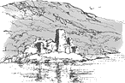
Finlarig
Drive east through Killin, and 400 yds past the Killin hotel you will see a bridge on the right over the river. Cross the bridge and in 250 yds, on the left, you'll see a wooded knoll. The Castle is on the knoll, but neglect has allowed it to fall into ruin. Finlarig was built in the early 1600s by Black Duncan of Glenorchy; probably the most feared of the acquisitions Campbell clan. He also built a chapel where the ruins of the mausoleum stand to the east of the castle on the mound. The mausoleum was built by the Campbells (of Breadalbane) in the early 1800s.
If you walk up to the castle, then face towards the mausoleum ruins, you'll see two gravestones side by side to the left. These stones mark the resting place of the Marquis and Marchioness of Breadalbane - the last of the Campbell line and descendants of Black Duncan of the cowl - who built this castle 1620's and the first mausoleum (also in ruins) behind the graves. (Don't miss the beheading pit to the north side of the castle - grizzly!)
Take care these ruins are dangerous! The castle consists of two towers and a passage past cellars to kitchen. The beheading pit with beheading block lies behind castle (to north)
Comrie Castle
Built 15th century by Menzies family it is thought to have been in intermittent use as a Menzies home until 1745 when the Menzies family moved to Castle Menzies after it's burning in 1487.
Driving east from Coshieville, after about 2 miles, take the next on the right over a little bridge and is on your left over the bridge. This castle is in a private garden and not open to the public.
Castle Menzies
The Menzies family (formerly Mengies) built their castle at Weem which was totally destroyed by Neil Stewart of Garth in the 16th Century.
Hugely extended by a new wing, in the 19th century it became derelict after its use by the armed forces during World War II, but has been restored by the Clan Menzies Society.
Three miles east of Coshieville, one mile west of Aberfeldy and on the north side of the road, you will see the castle across the field.
Bonnie Prince Charlie' stayed here for two nights in 1746. Four days later "Butcher" Cumberland stayed here on his way to Culloden.
The following is taken from ElectricScotland.com and concerns the Crannogs in Loch Tay. Crannog’s were artificial islands set in the shallows of lochs upon which the ancient’s constructed their dwellings. There is one on the north shore of Loch Tay very near to Killin and the Macnab’s great enemies, the MacNishes lived on one such on Loch Earn known today as Nish Island.
Following the link www.crannog.co.uk takes one to the Crannog web site
Crannogs and Clan Donnachaidh
Dr Nick Dixon and his American-born wife Barrie Andriaan have an obsession. Some 25 years ago Nick began his life’s work in exploring the crannogs - in fact one in particular - in Loch Tay. Since then he has uncovered a huge storehouse of artifacts and information about an aspect of Highland heritage that was virtually unknown. As a byproduct of his work, he and Barrie have also created one of the country’s premier visitor attractions as a way to raise money to continue their research.
Crannogs are artificial islands set in the shallows of lochs, most surviving today as little more than submerged boulder-mounds or islets topped by stands of trees. However, these defensive homesteads figured prominently throughout Scotland's past as flourishing waterborne communities that lasted for centuries and came to play an important part in clan refuge and warfare. They were occupied as early as the Neolithic period, some 5,000 years ago, until the 17th century AD.
Most Scottish crannogs appear to have consisted of a single thatched roundhouse, deliberately built out in the water for protection from wild animals and invaders. Based on the results of Nick’s underwater surveys and excavations, we now know that the crannogs were built as free-standing timber pile-dwellings in the lochs of woodland environments, and as circular or sub-circular stone buildings on man-made or modified natural rocky islands in more barren environments.
There are many crannogs in Ireland, one known example in Wales, but none in England. More than 400 are known in Scotland but, as there are more than 30,000 lochs in the country, the total number is likely to run into thousands. In Loch Tay, Perthshire, where Nick’s Scottish Trust for Underwater Archaeology has been excavating periodically since 1980, there are 18. At one of these, the late Bronze Age/early Iron Age site of Oakbank Crannog, water logging has made the preservation of organic materials spectacular. Surviving structural remains include the original pointed alder posts of the supporting platform, floor timbers and hazel hurdles forming walls and partitions, as well as the posts that once provided a walkway to the shore.
The finds from the site paint an amazingly clear picture of the lifestyle of the crannog-dwellers in the area, and increase our knowledge of this period in prehistory. Wooden domestic utensils, finely woven cloth, beads, and even food and plant remains have all been well preserved. We know that the crannog-dwellers kept cattle, sheep, goats, and pigs, and produced dairy products including butter, which in one instance was found still adhering to a wooden dish probably only discarded because it had split apart.
Most crannogs are situated opposite good agricultural land, and the discovery of a wooden cultivation implement at Oakbank Crannog, together with grain and pollen evidence, indicates a local population of peaceful farmers. They grew a range of cereal crops including spelt, an early form of wheat previously thought imported by the Romans. These loch-dwellers also cultivated a taste for parsley which is not indigenous to Scotland, and therefore perhaps indicative of trade with people further south or on the Continent.
The crannog-dwellers went to some trouble in search of the finer things in life. They supplemented their diet with a range of nuts and berries including hazelnuts, wild cherries and sloes, but they had to make an extra effort to pick cloudberries, which only grow up on the mountains. They also made special trips to higher ground to collect branches of pine to make tapers or `fir candles'.
Every discovery brings up more questions; and in an effort to address at least one unknown area, Nick and his team have constructed as authentically as possible a full-size crannog near Kenmore in the shallows of the south shore of Loch Tay. At the Crannog Centre is an exhibition displaying some of the finds and a chance for the visitor to actually try out some of the ancient technologies of the people who lived there three thousand years ago.
Two crannogs have particular associations with Clan Donnachaidh. In the north west corner of Loch Tummel, there was a small, partly artificial island on which Stout Duncan ‘built a strong house and a garden, which gave the name of Port-an-Eilean, or the Fort of the Island, to that place’ (Statistical Account [OSA] 1792) In 1913 it was described as being ’50 yds by 35 yds, standing in about 7' of water, but there is a deep channel between it and the shore. Carefully-laid stones appear to rest on trees.’ It was submerged in the post-war hydro-electric scheme but in the early 1970s ‘was briefly exposed when the water level was lowered and Mrs. Torry (Port an Eilean Hotel, Loch Tummel) saw stone slabs which she thought were steps, on the N edge of the island.
In 2004 Nick Dixon, as part of a survey of Perthshire crannogs dived over the site and reported ‘The top of the site is now 3m under water and is covered with the stumps of trees cut down before submergence. The remains are still very obvious of a well-made flagstone floor with a path leading to a flight of steps that went down to the loch bed, some 2m deeper. One of a number of upright timbers at the bottom of the stairs was sampled and produced a date of 110±50 BP (AD 1840).
The other clan crannog is Eilean nam Faoileag - the Island of Gulls - in Loch Rannoch which is now topped by a 19th century tower folly. In a 1969 survey it was ‘a completely stone built island now measuring 17.0m NS by 10.0m transversely. A considerable part of the island lies beneath the surface of the Loch which has been raised at least 6ft in the last 30 years. According to local information the sand bank on which it is constructed sweeps round in a gradual curve to meet the S shore and prior to the raising of the loch it formed a causeway just below the water.’
In the words of the MS first written by the Poet Chief ‘the King having defeated McDougall of Lorn somewhere in the hills betwixt Rannoch & Breadalbane and taken McDougall himself prisoner, committed him to Duncan’s care who conveyed him to the island of Loch Rannoch. McDougall obtained some freedoms upon his parole, but by an evasion of that parole grounded upon the ambiguity of the words in which it was expressed in the Gaelic Language he made his escape.’ The date for this incident is the early 1300s
During the survey of 2004, ‘A large oak timber, lying partly embedded under the stones on the E side of the mound, and wood from lower down on the W side were sampled for radiocarbon dating. The oak gave a date of 840±60 BP (AD 1110) and the lower sample produced 660±50 BP (AD 1290)’. These are preliminary results but they seem to place the crannog right in Stout Duncan’s time frame. It would be pleasant to speculate that Duncan himself managed the construction of the island.
References: Blundell, F O (1913 ) 'Further notes on the artificial islands in the Highland area', Proc Soc Antiq Scot, 47, 1912-13, 260, OSA (1791-9 ) The statistical account of Scotland, drawn up from the communications of the ministers of the different parishes, Sinclair, J (Sir), Edinburgh, Vol.2, 475-6,

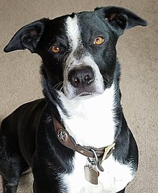
The McNab Dog - commonly called McNab Shepherd or McNab Collie - is a herding dog that originated in the Mendocino region of Northern California. The McNab was bred to withstand the tough conditions found in California such as heat, burrs, foxtails, and rugged terrain. Until recently, the McNab was little known outside California, but the last three decades have seen a gain in popularity and geographic dispersal of the breed
The appearance of the McNab can vary considerably. The dog is medium-sized with females standing 16-21 inches at the shoulder and weighing 30-50 pounds and males standing 18-25 inches at the shoulder and weighing 35-65 pounds. The dogs have a variety of ear sets from pricked ears to floppy ears and everything in between. Most McNabs are black or red with white feet, white collars, white facial strips and white tipped tails, but tricolor McNabs are well known as well as mostly black McNabs. Their eyes are set well apart, almond shaped, and brown, hazel, or copper colored. The McNab coat is close, dense and weather resistant. They can have a slick single short coat, a short double coat, or a medium length single coat, but their fur is never long. One of the distinctive features of the McNab is their cat-like feet which contribute to their agilityThe McNab is currently not recognized as a standardized breed by any major kennel club, including the American Kennel Club (AKC). This status may change in the future.
In 2014, a group of McNab Shepherd breeders and enthusiasts established the McNab Shepherd Registry (MSR). According to the MSR, their goal is to continue the betterment, advancement and welfare of the McNab Shepherd. The MSR is what is known as a "founding registry" because they exclusively utilize discovered genetic markers and DNA verification for registration.
Beginning in 2014, the MSR worked with Mars Veterinary on a study in an attempt to establish a unique genetic signature for the McNab Shepherd. Samples collected from McNabs across the United States were evaluated for their genetic signature and found to support the creation of a unique breed signature for the McNab. Additionally, the tested dogs were also evaluated for certain physical traits and over 100 disease-causing mutations to help establish a baseline for these in the McNab population
McNab Shepherds require more daily physical exercise and mental stimulation than many other breeds. A working McNab frequently runs for miles a day, using its herding skills to control livestock, and they can become restless if isolated or neglected. Unlike some other herding breeds, McNabs are not hyperactive. Providing a McNab has plenty of exercise, it is content to nap at its owner’s side with a watchful and protective eye.
McNabs often bond tightly to their family members, including other household pets. They have a keen sense of territory and seldom wander away from home. They are also more likely to defend their territory and family members than many of the more sensitive herding breeds.
McNabs can be assertive and demanding, and they do best with guardians who are firm, consistent and skilled in positive dog training methods that don't trigger the McNabs instinct to push back against obstacles. Highly intelligent and quick to learn, the McNab needs to exercise its brain as much as its body. Families considering a McNab for a pet will need to set aside plenty of time to spend with their dog
McNabs are hardy dogs with no breed specific health problems. Their average life span is 13–15 years.
McNab dogs may carry the MDR1 mutant gene and can be very sensitive to Ivermectin, which is a common ingredient in heartworm prevention medications. This drug and others can cause serious health problems or even death.[4] A DNA test that demonstrates whether a dog has the mutation is available through the Washington State University College of Veterinary Medicine. The test can be completed by sending them a cheek swab through the mail
McNabs have a loose-eyed herding style and tend to work more independently than many herding breeds. They are skilled at both heading and heeling stock, meaning they can turn stock from the front or get behind stock and drive them forward. Originally bred to herd sheep, stock handlers quickly discovered that the McNabs bold nature and working abilities made them ideal for herding cattle. McNabs are also used for herding geese, goats, llamas and gathering horses in from the pasture. Renowned for their incredible endurance, McNabs have been known to cover over a hundred miles a day driving their herds.[6]
McNabs are becoming increasingly popular in the world of dog sports. Their outstanding athletic prowess and agility coupled with high intelligence make them ideal competitors. McNabs are now competing successfully in agility trials, dock diving, disc dog competitions, and flyball. They are also exceptional competitors in barn hunt and nose work. Many ranchers are competing with McNabs in the relatively new sport of Ranch Dog Herding where dog and handler on horseback work as a team herding three head of cattle through five obstacles and then into a stock trailer.[7]
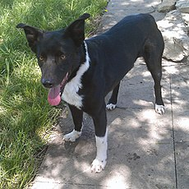
Black and white McNab Shepherd
The McNabs reputation as an indefatigable "all-weather" dog is also opening up a new avenue of work for the dog: Search and Rescue. Currently McNabs are working as evidence search dogs, cadaver dogs, archaeology dogs, and area search dogs for missing persons. Where many other breeds have to be pulled off the search because the dog is tiring, the only limitation for the McNab is the energy of its handler.
In addition to the above activities, McNabs are now becoming more common as service dogs, demonstrating sensitivity to the medical and psychological needs of humans
Alexander McNab left his native Scotland in the late 19th Century homesteading his 10,000 acre sheep ranch located in the Sanel Rancho, which later became Hopland, California. Looking to develop a herding dog that could handle the rough conditions on his ranch, McNab crossed the Scottish Collies he brought with him with the tough dogs of the nomadic Basque sheepherders he met near his ranch. McNab aptly called his dogs “McNab Shepherds.”[8]
In the early 1900s, the elder McNab passed the ranch down to his youngest son, John McNab, an attorney and stockman who reinvigorated his father’s breeding style. Refinement of the McNab Shepherd continued and additional dogs were imported from Scotland for breeding and ranching purposes.[9]
Over time, the McNab dogs proved to be supreme herding dogs which California ranchers came to depend on with confidence. Now the breed is spreading across the United States and Canada with a few McNabs working as stock dogs in Germany and some sporting McNabs as far away as Japan

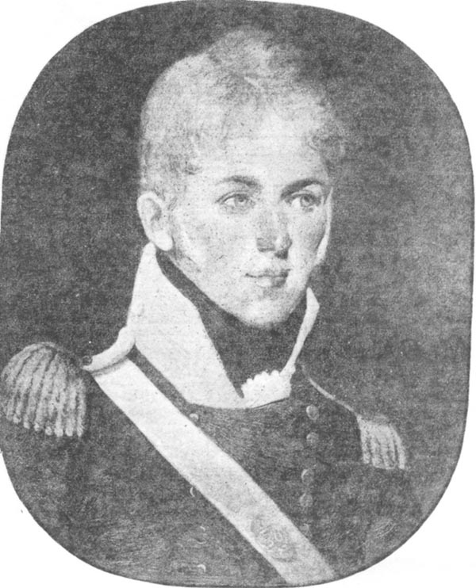
A Canadian Peninsular and Waterloo Man: The Story of Captain Alexander Macnab, 2/30th Foot
By John R. Grodzinski
Captain Alexander Macnab (? – 1815) Painting by an unknown artist. (Author’s Collection)
Alexander Macnab [1] was second son of Dr James Macnab, who served as assistant surgeon to Major McAlpin’s Corps of Loyalists raised in the Colony of New York, during the American War of Independence. James Macnab had settled near Norfolk, Virginia, where Alexander would be born. [2] Following the war, James’ property was confiscated and like many Loyalists, he went to Canada and died at Machiche, in the Province of Quebec in 1780. [3]
Some years after his father’s death, Alexander took up residence in York (later Toronto) in Upper Canada, where he came to own “a considerable property” on Bay Street at the junction of Queen and Dundas Streets. In 1797, he was sworn in as confidential clerk to the Executive Council of Upper Canada at Newark, the provincial capital, now known as Niagara on the Lake. Three years later, he turned his pen in for a sword and commenced a military career.[4] On 28 February 1800, Alexander became an ensign in The Queen’s Rangers, a colonial regular unit formed in 1791 and comprised largely of Loyalists; Alexander served as adjutant on the regimental staff.[5] When the regiment was disbanded in October 1802, Alexander decided to join the British Army and served initially with the 26th Foot before moving to the 2nd Battalion, 30th Foot, where on 16 January 1804, he was promoted to lieutenant.[6] He remained on the roll of the junior battalion of this regiment from then until his death in 1815.[7]
The 30th (Cambridgeshire) Regiment had a long and distinguished service since its formation in 1689. The Revolutionary and Napoleonic Wars took it to many places, including Messina, Valetta, Egypt, Java, Macao, and India. Until 1803, every “regiment” consisted of single battalion of roughly 1,000 men. As the British army was expanded during the war, new regiments were raised, while many existing regiments raised a second battalion. Preference for service normally went to the senior battalion, which also enjoyed priority for replacement personnel, whether they were officers or recruits from the regimental depot. Either way, this was done at the cost of the junior battalion. Normally one battalion was on active service, while the other was at “home.” Occasionally, all the battalions of a regiment saw active service overseas and such was the case for the 30th Regiment of Foot. [8]
The second battalion of the 30th Foot, or 2/30th Foot, was raised in July 1803 at Chelmsford, England and was soon sent to Ireland. In March 1809, the battalion sailed from Cork to Lisbon, landing there on April 7th. During May, the battalion was sent to replace another unit in Gibraltar. In April 1810, five companies [9] were sent to drive the French from Tarifa. By June the battalion was at Cadiz and in October, it sailed for Lisbon, where it joined the 5th Infantry Division, just recently created in Wellington’s army. The battalion was soon in the field and although present at Fuentes de Oñoro in May 1811, it did not see any action, although four soldiers were wounded. The battalion remained largely inactive until March 1812 when it participated in the siege of Badajoz. During the assault on the town on 6 April, it escaladed the walls of the San Vincente Bastion, losing 130 men in the process. In July 1812, the battalion was at Salamanca, where it lost another 27 men. The 2/30th Foot was present at the siege of Burgos and during the retreat fought a sharp rear guard action at Villa Muriel. By December 1812, casualties, illness and the lack of reinforcements had reduced the strength of the battalion [10] and six skeleton companies were sent home to recruit, while the rest were combined with four companies of another weak battalion, the 2/44th Foot, to form the 4th Provisional Battalion, 5th Division. Wellington preferred grouping under strength units in this way as it allowed veteran troops to remain in his army, rather than be replaced by less experienced regiments from home. This arrangement continued until May 1813, when the provisional unit was ordered home and was broken up, with the remaining soldiers of the 2/30th rejoining the battalion, now at Jersey in the Channel Islands. Later that year, the battalion sailed to Bergen-op-Zoom and remained in Antwerp at the close of the campaign. It was still there in March 1815, when it was learned that Napoleon had escaped Elba. [11]
In May 1809, two companies were added to the establishment of the 2/30th Foot in order to form a depot and Lieutenant Alexander Macnab received command of one of the new companies “without purchase.” Rather than serve with the depot, Alexander went to the battalion, joining it in Portugal in 1809. Alexander was not the first Canadian or person associated with Canada to serve in the Iberian Peninsula; Lieutenant Edward de Salaberry, Royal Engineers and Captain Francis Simcoe, 3/27th Foot, son of the John Graves Simcoe, the first Lieutenant Governor of Upper Canada, were both killed at Badajoz on 6 April 1812. [12]
Throughout its peninsular service, the 2/30th Foot suffered from having too few officers. Sickness, detached duty and casualties left many vacancies; unfortunately, for Alexander, this did not translate into field duty with the battalion and he was employed on the staff. In January 1810, Alexander was appointed town major of Gibraltar until his battalion returned to Lisbon. The battalion joined the 5th Division at Sobral, about 22 miles from Lisbon. At this time, Wellington’s army was drawn up behind the Lines of Torres Vedras. Alexander was listed as being effective at the battalion, but had to remain behind at Lisbon due to illness, which may have influenced his future employment. By March 1811, the French had withdrawn from the Lines, Wellington went on the offensive and Alexander had recovered. Instead of rejoining his battalion, Alexander was sent north and was appointed commandant of the important coastal port of Figuera, at the mouth of the Mondego River. On 11 May 1809, Alexander was promoted to captain. [13] When the 2/30th Foot joined the 4th Provisional Battalion in 1812, Alexander was still at Figuera, although his commanding officer may have attempted to get him back into the battalion. Despite the absence of nearly every captain from the battalion, Lieutenant Colonel Alexander Hamilton, the commanding officer, was unable to pry any of them serving on the staff away from Wellington’s grasp. The war ended in April 1814 and Alexander appears to have left Portugal for England sometime in August or September 1814. In October, he was ordered to join the battalion at Antwerp. Captain Macnab is shown on one roll [14] as being in command of No. 4 Company; however he was then appointed to General Picton’s staff, on a date and for reasons unknown. Alexander just seems to have been one of those officers that experienced minimal regimental duty. [15]
As stated, the 2/30th Foot was at Antwerp when Napoleon escaped from Elba. It soon joined the allied force being organized for the coming campaign and was allotted to the 3rd British Infantry Division, under Lieutenant General Sir Thomas Picton. At Waterloo the 2/30th was placed on the west side of the crossroads of Mont St Jean. Alexander Macnab was not with his battalion as he had been seconded as an aide de camp to Picton. Neither Picton’s memoirs nor any other source consulted on Waterloo mention this appointment, yet the history of the 30th Regiment and Dalton’s Waterloo Roll Call confirm it was made. It remains uncertain whether Alexander was actually employed as an aide or elsewhere within the headquarters, so his fate is known. During the Waterloo campaign, Picton had four ADCs and the group proved to be an unlucky lot; Picton, still suffering from wounds received at Quatre Bras on 16 June, was shot through the head while leading his men forward to repulse a French attack. Captain J. Tyler, had been with Picton in the Peninsula, was wounded at Quatre Bras and was with Picton when he died; Captain Algeron Langton suffered wounds at Quatre Bras; and Captain N. Chambers was killed shortly after Picton fell. Barrington Price was a half-pay captain employed as an extra aide de camp; he was wounded by French cuirassiers at Waterloo and died a few months later. Alexander may have been at Quatre Bras and at Waterloo was mortally wounded at some point during the battle. As he lay dying, his orderly remained with him. Alexander apparently instructed his orderly to convey his watch, ring, sword, and regimental sash, along with some messages, to his family in Scotland and Canada. Upon his death, Alexander was buried on the battlefield. He was one of six officers from his regiment killed during the battle. In 1903, the sword and watch were still with Alexander’s nephew, Canon Alexander Wellesley Macnab in Toronto. [16] Alexander was ineligible for the Military General Service Medal, which was instituted in 1847 but not awarded posthumously; however he was eligible for the Waterloo Medal, the first British campaign medal “awarded to next of kin of men killed in action” and issued in 1816. However, the application for the medal was not make until 1868, when his nephew, Dr A. Macnab, Rector of Darlington, applied to the War Office, requesting a Waterloo Medal for his uncle Alexander. A medal was named to him, impressed as “Captain Alex. Macnab, 2nd Battalion, 30th Regiment,” and was presented by the Duke of Cambridge. Unfortunately, the current location of this medal is unknown despite an extensive search. [17]
The tablet honoring Captain Alexander Macnab in St Paul’s Cathedral, London, forming part of a “Canadian Corner.” A bust of the first Prime Minister of Canada, Sir John A. Macdonald, is nearby. It is unusual to find a tablet to so undistinguished an officer in such an honored place for the tomb of the first Duke of Wellington lies just beyond this tablet. (Author’s Collection) At some point, Alexander’s nephew had a chance meeting with a former officer from the 30th Foot, Arthur Gore (Goore), and described him as Alexander’s “greatest friend.” During their meeting in England, Gore related something of Alexander’s character; he was very “popular with the officers and men of his regiment…brave and steady in time of danger…patient and God fearing in fulfilling his obligations in camp or the battlefield.” Apparently just prior to Waterloo, Alexander and the then Captain Gore,[18] as was the custom at the time, “took snuff with each other” and “with a clasp of the hand parted, never to meet again.” Unfortunately, the specifics of Alexander’s fate, if they were discussed, were not recorded. [19]
In 1876, the Dean and Chapter of St Paul’s Cathedral permitted the placing of a marble tablet in the crypt of the basilica in the memory of Alexander Macnab, the first colonial memorial to be erected there. The tablet was unveiled in September 1876 and among those present were Alexander’s nephew, Rev A. Macnab and his son, Rev A.W. Macnab. The tablet is located in the archway, near the memorial to Sir John A. Macdonald, the first Prime Minister of Canada and close to the crypt of the first Duke of Wellington, a most honorable location to a junior officer with such an unspectacular career. [20]
A monument was also placed in the northwest transept for Sir Thomas Picton and one of the mourners present for the second funeral service that coincided with the unveiling, was the Reverend Dr McNabb, nephew of Alexander.[21]
Thus ends the story of yet another “Canadian” who saw service with the British Army during the Napoleonic Wars. While several Canadians served in the Peninsula and elsewhere during this period, Macnab’s experience was unique, as he appears to be the sole “Canadian” to be at Waterloo. His military career was not particularly spectacular and is noteworthy for his limited regimental duty. Although most of his time was spent on the staff, the story of Captain Alexander Macnab is indeed interesting and part of the fabric of this incredible period.
Notes:
[1] It should be noted that various spellings of this name appear in the sources, including McNab, McNabb, M’Nabb, MacNab and Macnabb. The form “Macnab” will be used in this article as it appears to be the one used by the family.
[2] None of the sources consulted have revealed a birth date for Alexander.
[3] Macnab, Canon Alexander, “A Canadian U.E. Loyalist at Waterloo,” Annual Transactions of the United Empire Loyalists’ Association of Ontario, Toronto, 1903, p. 73. Firth, Edith G. The Town of York, 1793 – 1815: A Collection of Documents of Early Toronto. Toronto: The Champlain Society, 1962, p. 69n34.
[4] This military career may have commenced earlier, as Alexander is shown on the regimental roll for 1797; see Firth, Edith G. The Town of York, 1793 – 1815: A Collection of Documents of Early Toronto. Toronto: The Champlain Society, 1962, p. 69. Canon Alexander Macnab, “A Canadian U.E. Loyalist at Waterloo,” Annual Transactions of the United Empire Loyalists’ Association of Ontario, Toronto, 1903, p. 77.
[5] “Officer’s of the York Militia, 1798,” Firth, Edith G. The Town of York, 1793 – 1815: A Collection of Documents of Early Toronto. Toronto: The Champlain Society, 1962, p. 69. Army List, 1803, p. 229.
[6] Army List 1806, p. 170.
[7] Bannatyne, Lieutenant-Colonel Neil. History of the Thirtieth Regiment Now the First Battalion, East Lancashire Regiment, 1689 – 1881.Liverpool: Littlebury Bros., 1923, p. 463.
[8] Some regiments had more, such as the 60th with six battalions, the Royal Scots, which had four battalions, the 1st Foot Guards, 14th, 27th and 95th, which had three each. See Oman, Sir Charles. Wellington’s Army, 1809 – 1814. London: Greenhill Books, 2006, p. 178 – 179, 181.
[9] This force included the grenadier company, light company and three line companies. See Bannatyne, Lieutenant-Colonel Neil. History of the Thirtieth Regiment Now the First Battalion, East Lancashire Regiment, 1689 – 1881.Liverpool: Littlebury Bros., 1923, p. 244.
[10] The poor state of the battalion is reflected in a return dated 25 December 1812, showing the 2/30th Foot with only 206 effective rank and file and 317 rank and file sick or wounded! Bannatyne, Lieutenant-Colonel Neil. History of the Thirtieth Regiment Now the First Battalion, East Lancashire Regiment, 1689 – 1881.Liverpool: Littlebury Bros., 1923, p. 292.
[11] Bannatyne, Lieutenant-Colonel Neil Bannatyne. History of the Thirtieth Regiment Now the First Battalion, East Lancashire Regiment, 1689 – 1881.Liverpool: Littlebury Bros., 1923, p. 242, 248. Reid, Stuart. Wellington’s Army in the Peninsula, 1809 – 1814. London: Osprey
Publishing, 2004, p. 58, 59 Glover, Michael. The Peninsular War, 1807 – 1814. London: Penguin, 2001, p .360. Fletcher, Ian. Wellington’s Regiments: The Men and Their Battles. Staplehurst: Spellmont, 2005, p. 151, 152. Oman, Sir Charles. A History of the Peninsular War, Volume IV. London: Greenhill Books, 2004, p. 623. Oman, Sir Charles. A History of the Peninsular War, Volume V. London: Greenhill Books, 2005, p. 594, 596. Oman, Sir Charles. A History of the Peninsular War, Volume VI. London: Greenhill Books, 2005, p. 79.
[12] Bannatyne, Lieutenant-Colonel Neil History of the Thirtieth Regiment Now the First Battalion, East Lancashire Regiment, 1689 – 1881.Liverpool: Littlebury Bros., 1923, p. 243. For the story of Lieutenant Edward de Salaberry, see Grodzinski, John R. “Universally Esteemed by His Brothers in Arms: Lieutenant Edward de Salaberry, R.E. at Badajoz, 6 April 1812.” Napoleon Series website at http:
www.napoleon-series.org/ Simcoe’s story is recounted at Fryer, Mary Babcock. Our Young Soldier: Lieutenant Francis Simcoe, 6 June 1791 – 6 April 1812. Toronto: Dundurn Press, 1996. [13] Army List, 1812, p. 188. Dalton, Charles. The Waterloo Roll Call. London: Arms and Armour Press, 1971, p. 140.
[14] Another list for the time of Badajoz, April 1812, shows Macnab with No. 1 Company, although he never held this appointment. Both these entries may simply be an administrative means for the battalion to account for him rather than showing his actually employment. It may be strange for some readers to learn that similar problems plague armies today. Despite digitization, lists are rarely up to date and not always accurate. For the Badajoz list, see Bannatyne, Lieutenant-Colonel Neil. History of the Thirtieth Regiment Now the First Battalion, East Lancashire Regiment, 1689 – 1881.Liverpool: Littlebury Bros., 1923, p.273.
[15]Bannatyne, Lieutenant-Colonel Neil. History of the Thirtieth Regiment Now the First Battalion, East Lancashire Regiment, 1689– 1881.Liverpool: Littlebury Bros., 1923, p. 244, 246, 247, 250, 273, 292, 295, 307, 348. An entry appears on page 203 for “Captain McNabb Alexr., Killed 18th June.” Macnab is listed with Captain Henry Cramer’s company.
[16] Bannatyne, Lieutenant-Colonel Neil. History of the Thirtieth Regiment Now the First Battalion, East Lancashire Regiment, 1689 – 1881.Liverpool: Littlebury Bros., 1923, p. 347, 348. Dalton, Charles. The Waterloo Roll Call. London: Arms and Armour Press, 1971, p. 15. Robinson, H.B. Memoirs of Lieutenant-General Sir Thomas Picton, Volume II. London: Richard Bentley, 1836, p. 389. Macnab, Canon Alexander, “A Canadian U.E. Loyalist at Waterloo,” Annual Transactions of the United Empire Loyalists’ Association of Ontario, Toronto, 1903, p. 78.
[17] Macnab, Canon Alexander, “A Canadian U.E. Loyalist at Waterloo,” Annual Transactions of the United Empire Loyalists’ Association of Ontario, Toronto, 1903, p. 77. The author wishes to acknowledge the assistance of Jay Medves in attempting to learn details of Macnab’s Waterloo Medal. Joslin, E.C., Litherland, A.R., Simpkin, R.T.. British Battles and Medals. London: Spink, 1988, p. 69, 86. The Waterloo Medal Roll: Compiled from the Muster Rolls. The Naval and Military Press, 1992. The entries for the 2/30th Foot appear on pages 201 – 226. [18] Gore was wounded at the battle and later rose to become a lieutenant general. See Dalton, Charles. The Waterloo Roll Call. London: Arms and Armour Press, 1971, p. 140 and 142n6.
[19] Macnab, Canon Alexander, “A Canadian U.E. Loyalist at Waterloo,” Annual Transactions of the United Empire Loyalists’ Association of Ontario, Toronto, 1903, p. 77.
[20] Macnab, Canon Alexander, “A Canadian U.E. Loyalist at Waterloo,” Annual Transactions of the United Empire Loyalists’ Association of Ontario, Toronto, 1903, p. 78.
[21] Dalton, Charles. The Waterloo Roll Call. London: Arms and Armour Press, 1971, p. 142. “Casualties since last publication-Deaths,” Army List 1816, N.P. Robinson, H.B. Memoirs of Lieutenant-General Sir Thomas Picton, Volume II. London: Richard Bentley, 1836, p. 394.

At dawn on December 31, 1944, while the Battle of the Bulge raged, two young airmen took off from Thorpe Abbotts, England, and flew their Boeing B-17G Flying Fortress in formation with hundreds of others in what was to be a ‘maximum effort’ over Germany by every available flier. That New Year’s Eve would soon require the maximum effort these two men could muster to stay alive in what has to be considered one of the most unlikely incidents in aerial history.
It was the 22nd mission for 1st Lt. Glenn H. Rojohn, a native of Greenock, Pa., the pilot of B-17 No. 42-231987, and 2nd Lt. William G. Leek, Jr., from Washington State, his co-pilot. Both men had been scheduled for leave after flying several missions in a row. But their plans were interrupted at 4 a.m. that day when they were awakened for the so-called maximum effort, which meant, as Rojohn later explained, ‘Everyone flies.’ Thirty-seven heavy bombers took off with the 100th Bomb Group that day. Only 25 planes returned to England.
Following breakfast and briefing at the base, home to members of the 100th Bomb Group from June 1943 to December 1945, Rojohn and Leek learned that their target would be Hamburg, a port city with numerous oil refineries and submarine pens. Second Lieutenant Robert Washington, the ship’s navigator, recalled the start of that, his 27th, mission: ‘Takeoff on the morning of December 31, 1944, was delayed because of fog, and when we assembled the group and departed the coast of England, we learned that the fighter escort had been delayed due to the weather.’
It took ‘almost as much time to rendezvous to go on a mission as it did to complete a mission,’ Rojohn recalled, ‘because the weather in England was always bad, and we had to circle around and around until we broke out above the overcast. Our squadrons [Rojohn flew in C Squadron] then formed, and we met other groups until we got into a long line of traffic heading toward Germany. This particular day we flew over the North Sea to a point south of Denmark and then turned southwest down the Elbe River to Hamburg. We were somewhere in the neighborhood of 25,000 feet [altitude]. At that time I don’t think much was known about the jet stream, but we had a tail wind of about 200 nautical miles an hour. We got into the target pretty quick. Over the target, we had just about everything but the kitchen sink thrown at us.’
Leek’s recollections of the Hamburg mission were equally vivid: ‘The target and the sky over it were black from miles away. The flak was brutal. We flew through flak clouds and aircraft parts for what seemed like an hour.’
While Rojohn does not like to criticize his commanding officers, he thinks a mistake was made that day. ‘Instead of hitting the target and angling out over Germany still on a southwesterly direction and then out over Belgium, they turned us at 180 degrees back toward the North Sea,’ Rojohn said. ‘So an 80-knot tailwind became an 80-knot headwind. We were probably making about 50 or 60 mph on the ground.’
‘When we finally got clear of the coastal flak batteries,’ recalled Washington, ‘we turned west and skirted the flak area by flying between Heligoland and Wilhelmshaven. The flak was heavy as we crossed the coastline. I’m not certain whether we headed northwest between Bremerhaven and Kuxhaven, or due west over the little town of Aurich and across the coastline near Norden.’
Over the North Sea, Rojohn remembered, they were flying at 22,000 feet when they ‘encountered wave after wave of German fighters. We just barely got out over the North Sea, and the sky was rumbling around us with exploding flak and German [Messerschmitt] Me-109 fighter planes so close I could see the faces of the young German pilots as they went by. They were just having a field day with our formation. We lost plane after plane.’
According to an account written by Tech. Sgt. Orville E. Elkin, Rojohn’s top turret gunner and engineer: ‘The fighters came from every direction, 12 o’clock, 6 o’clock, from the bottom and from the top. Your body becomes cold and numb from fright as you realize that only one-sixteenth of an inch of aluminum stands between you and this battery of firepower.’ Ten planes were quickly lost.
Leek had been at the controls when the crew came off the bomb run. He and Rojohn alternated the controls each half hour. ‘On this mission,’ Leek recalled, ‘the lead plane was off Glenn’s wing, so he flew the bomb run. I should have kept the controls for at least my half-hour, but once the attack began, our formation tightened up and we started bouncing up and down. Our lead plane kept going out of sight for me. I may have been overcorrecting, but the planes all seemed to bounce at different times. I asked Glenn to take it, and he did.’
Rojohn maneuvered to take a position to fill the void created when a B-17 (No. 43-338436) piloted by 2nd Lt. Charles C. Webster went down in flames and exploded on the ground. ‘I was going into that void when we had a tremendous impact,’ Rojohn recalled. Feeling the bomber shudder, the men immediately thought their plane had collided with another aircraft. It had, but in a way that may never have happened before or since.
Another B-17 (No. 43-338457), piloted by 1st Lt. William G. MacNab and 2nd Lt. Nelson B. Vaughn, had risen upward. The top turret guns on MacNab’s plane had pierced through the aluminum skin on the bottom of Rojohn’s plane, binding the two huge planes together, as Leek said, like ‘breeding dragonflies.’ The two planes had become one.
Whether MacNab and Vaughn lost control of their plane because they were seriously injured or the planes collided because both Rojohn and MacNab were moving in to close the open space in the formation is uncertain. Both MacNab and Vaughn were fatally injured that day and were never able to tell their own story.
Staff Sergeant Edward L. Woodall, Jr., MacNab’s ball-turret gunner, remembered that when a crew check was called just prior to the midair collision, everyone had reported in. ‘At the time of the impact,’ Woodall said, ‘we lost all power and intercom on our aircraft. I knew we were in trouble from the violent shaking of the aircraft, no power to operate the turret, loss of intercom, and seeing falling pieces of metal. My turret was stalled with the guns up at about 9 o’clock. This is where countless time drills covering emergency escape procedures from the turret paid off, as I automatically reached for the hand crank, disengaged the clutch and proceeded to crank the turret and guns to the down position so I could open the door and climb into the waist of the airplane. I could see that another aircraft was locked onto our aircraft and his ball turret jammed down inside our aircraft.’
In the 1946 book The Story of the Century, John R. Nilsson reported that E.A. Porter, a pilot from Payton, Miss., who witnessed the midair collision, had sounded the warning over the radio: ”F for Fox, F for Fox, get it down!’ — however MacNab, whose radio was dead, did not hear. Not to see the collision which seemed inevitable, Porter turned his head, while two of his gunners, Don Houk of Appleton City, Missouri, and Clarence Griffin of Harrisburg, Illinois, watched aghast, as MacNab and Rojohn settled together ‘as if they were lifted in place by a huge crane,’ and many of the 100th’s anguished fliers saw the two Fortresses cling — Rojohn’s, on top, riding pick-a-back on MacNab’s, how held together being a mystery. A fire started on MacNab’s ship, on which three propellers still whirled, and the two bombers squirmed, wheeled in the air, trying to break the death-lock.’
Washington opened the escape hatch and’saw the B-17 hanging there with three engines churning and one feathered. Rojohn and Leek banked to the left and headed south toward land.’
‘Glenn’s outboard prop bent into the nacelle of the lower plane’s engine,’ recalled Leek. ‘Glenn gunned our engines two or three times to try to fly us off. It didn’t work, but it was a good try. The outboard left engine was burning on the plane below. We feathered our propellers to keep down the fire and rang the bail-out bell.’
‘Our engines were still running and so were three on the bottom ship,’ Rojohn said. When he realized he could not detach his plane, Rojohn turned his engines off to try to avoid an explosion. He told Elkin and Tech. Sgt. Edward G. Neuhaus, the radio operator, to bail out of the tail, the only escape route left because all other hatches were blocked.
‘The two planes would drop into a dive unless we pulled back on the controls all the time,’ wrote Leek. ‘Glenn pointed left and we turned the mess toward land. I felt Elkin touch my shoulder and waved him back through the bomb bay. We got over land and [bombardier Sergeant James R.] Shirley came up from below. I signaled to him to follow Elkin. Finally Bob Washington came up from the nose. He was just hanging on between our seats. Glenn waved him back with the others. We were dropping fast.’
As he crawled up into the pilot’s compartment before bailing out, Washington remembered, ‘I saw the two of them [Rojohn and Leek] holding the wheels against their stomachs and their feet propped against the instrument panel. They feathered our engines to avoid fire, I think. [Shirley] and I went on through the bomb bay and out the waist door, careful to drop straight down in order to miss the tail section of the other plane which was a little to the right of our tail.’ Because of Rojohn’s and Leek’s physical effort, Shirley, Elkin, Washington, Staff Sgt. Roy H. Little (the waist gunner), Staff Sgt. Francis R. Chase (the replacement tail gunner), and Neuhaus were able to reach the rear of the plane and bail out. ‘I could hear Russo [Staff Sgt. Joseph Russo, Rojohn’s ball-turret gunner] saying his Hail Marys over the intercom,’ Leek said. ‘I could not help him, and I felt that I was somehow invading his right to be alone. I pulled off my helmet and noticed that we were at 15,000 feet. This was the hardest part of the ride for me.’
Before they jumped, Little, Neuhaus and Elkin took the hand crank for the ball turret and tried to crank it up to free Russo. ‘It would not move,’ Elkin wrote. ‘There was no means of escape for this brave man.’
‘Awhile later,’ recalled Leek, ‘we were shot at by guns that made a round white puff like big dandelion seeds ready to be blown away. By now the fire was pouring over our left wing, and I wondered just what those German gunners thought we were up to and where we were going! Before long, .50-caliber shells began to blow at random in the plane below. I don’t know if the last flak had started more or if the fire had spread, but it was hot down there!’ As senior officer, Rojohn ordered Leek to join the crew members and jump, but his co-pilot refused. Leek knew Rojohn would not be able to maintain physical control of the two planes by himself and was certain the planes would be thrown into a death spiral before Rojohn could make it to the rear of the plane and escape. ‘I knew one man left in the wreck could not have survived, so I stayed to go along for the ride,’ Leek said.
And what a ride it was. ‘The only control we actually had was to keep [the planes] level,’ said Rojohn. ‘We were falling like a rock.’ The ground seemed to be reaching up to meet them.
Washington recalled that, from his vantage point while parachuting, ‘I watched the two planes fly on into the ground, probably two or three miles away, and saw no more chutes. Shirley was coming down behind me. When the planes hit, I saw them burst into flames and the black smoke erupting.’
At one point, Leek said, he tried to beat his way out through the window with a Very pistol: ‘Just panic, I guess. The ground came up faster and faster. Praying was allowed. We gave it one last effort and slammed into the ground.’ As they crashed in Germany at Tettens, near Wilhelmshaven, shortly before 1 p.m., Rojohn’s plane slid off the bottom plane, which immediately exploded. Alternately lifting up and slamming back into the ground, the remaining B-17 careened ahead, finally coming to rest only after the left wing sliced through a wooden headquarters building, as Rojohn recalled, ‘blowing that building to smithereens.’ Russo is believed to have been killed when the planes landed
When my adrenalin began to lower, I looked around,’ Leek said. ‘Glenn was OK and I was OK, and a convenient hole was available for a fast exit. It was a break just behind the cockpit. I crawled out onto the left wing to wait for Glenn. I pulled out a cigarette and was about to light it when a young German soldier with a rifle came slowly up to the wing, making me keep my hands up. He grabbed the cigarette out of my mouth and pointed down. The wing was covered with gasoline.’
Rojohn and Leek sustained only slight injuries from the crash, which shocked even the two pilots when they took a look at the wreckage of their B-17. ‘All that was left of the Flying Fortress was the nose, the cockpit, and the seats we were sitting on,’ Rojohn later recalled.
Following their capture, Rojohn said, he and Leek were forced to undress so they could search us for weapons, which we had thrown out on the way down. They put us into a truck and drove through the countryside to pick up the survivors. The Germans then put us all into an old schoolhouse where we were finally able to talk with each other.’
Even though their lives were now in the hands of the Germans, the Americans were able to find a little humor in the situation. ‘Our captors didn’t know what to do with us because we were in a part of Germany where they didn’t take many captives,’ Rojohn said. ‘They put us in a dark, damp building way out in nowhere. All of a sudden the door opened up and everybody popped to attention. A German captain came in and barked something to his men. I didn’t understand what he had said, but Berkowitz [2nd Lt. Jack Berkowitz, MacNab’s navigator] heard the same words and fainted dead away. The next day they brought us back to the schoolhouse. Berkowitz, the only one of us who could understand German, told us the German captain had said, ‘If they make a move, shoot ‘em.’ That was too much for him and he fainted.’
Watching the planes fall piggyback to earth, German soldiers on the island of Wangerooge could not believe what they were seeing — ‘crazy Americans flying with eight motors.’ In fact, the Germans were so concerned that the Americans had developed a devastating new weapon that Berkowitz was shipped to an interrogation center in Frankfurt, Germany, and put into solitary confinement. After questioning him for two weeks, his interrogators gave up on the idea of a new American aircraft threat, and Berkowitz was transferred to a prison camp near the North Sea.
Seventeen-year-old Rudolf Skawran, who was shooting at the American bomber formations from Wangerooge, said his fellow soldiers were ordered by flak commander Captain Dinkelacker to leave the connected planes alone. Dinkelacker wrote in his log book at 12:47 p.m. that day, ‘Two Fortresses collided in a formation in the NE. The planes flew hooked together and flew twenty miles south. The two planes were unable to fight anymore. The crash could be awaited so I stopped the firing at these two planes.’ There was no way for Rojohn, Leek or the crew members to know that the Germans on the ground had ceased firing at them.
Civilians on Wangerooge stood and watched with amazement as the two planes flew over them. The youngest spectators ran to Rojohn’s plane and removed what they could get away with quickly — a machine gun and ammunition, some rations and chewing gum.
Little and Chase did not survive their jumps from the plane. Technical Sergeant Herman G. Horenkamp, Rojohn’s friend and the tail gunner for all of his 21 previous missions, had not reported for the mission that day because he had frostbite from the mission the previous day. Chase, who Rojohn and Leek had never seen before and never did meet face to face, was Horenkamp’s replacement that fateful day.
All of the survivors from the B-17 piloted by Rojohn were captured by the Germans almost immediately, as were four other men who bailed out of MacNab’s plane — 2nd Lt. Raymond E. Comer, Jr., Tech. Sgt. Joseph A. Chadwick, Berkowitz and Woodall.
Woodall told Rojohn years later that he was grateful to him and Leek because they carried him for several miles when broken bones sustained in his parachute landing kept him from walking after his capture. Rojohn has no recollection of that.
After the war, like thousands of other soldiers, Glenn Rojohn came back home to marry and raise a family. He eventually went to work with his brother Leonard in their father’s air conditioning and plumbing business in McKeesport, Pa. Rojohn, who received the Distinguished Flying Cross and the Purple Heart, said he owes his life to Leek: ‘In all fairness to my co-pilot, he’s the reason I’m alive today. He refused my order to bail out and said ‘I’m staying with you.’ One of us could have gotten out of that plane. He’s the reason I’m here today.’
Rojohn searched for 40 years through Social Security and veterans’ records to find his co-pilot, Leek, but was unsuccessful until 1986, when he was given a telephone number in the state of Washington. Rojohn called the number and reached Leek’s mother, who asked him if he wanted to talk to Bill, who was visiting from California at the time. The two pilots were reunited for one week in 1987 at a 100th Bomb Group reunion in Long Beach, Calif. Leek died the following year.
But Robert Washington, the navigator that day over the North Sea, still remembers the pilots’ remarkably cool handling of the bizarre situation. ‘Glenn said that he doesn’t consider himself a hero; but I do!’ said Washington. ‘I will never forget his calm, matter-of-fact response as I paused at the flight deck on my way out through the bomb bay and waist door. He may have said, ‘Get on out, Wash,’ or merely motioned with his head, but I knew he and Bill Leek had made their decision and several of us who jumped over land probably owe our lives to their courage.’
This article was written by Teresa K. Flatley and originally appeared in the May 1997 issue of World War II.
http://www.historynet.com/bizarre-b-17-collision-over-the-north-sea-during-world-war-ii.htm/5

Known as Ian Glas or Grey John, it was written that “he has the gravity of a Spaniard, is as cunning a fox, wise as a Serpent and slippery as an Eel,”
Chill (Fh) inn = Chill-inn which could have become Killin David Rorer
See the article on the Culdees, which follows.

